**Per Cent For Art – N25 New Ross Bypass**

The N25 New Ross Bypass PPP Project comprises a 14km dual carriageway road including new sections of both the N25 and N30 National Primary Routes. The bypass commences at a roundabout junction with the existing N25 at Glenmore, Co. Kilkenny before crossing over the River Barrow on a 3 tower extrados bridge extending for approximately 900 metres from Pink Point in County Kilkenny to Stokestown in County Wexford and continuing until it ties in with the N30 at Corcorans Cross. A landmark River Barrow Bridge “Rose Fitzgerald Kennedy” crossing connects Pink Point in County Kilkenny and Stokestown in County Wexford. This Extrados type bridge, at 900m, is the longest bridge in Ireland and the longest bridge of this type in the world.

In October, 2017 it was decided by the Public Art Working group of Wexford County Council that the N25 New Ross By Pass would have a permanent public art piece commissioned with funding through the N25 Per cent for Art Scheme and New Ross Municipal District.

After a limited competition, in which 20 leading artists nationwide were invited to submit expression of interest, 10 artists accepted Wexford County Council’s invitation with expressions of interest in February, 2018. Six of these artists were shortlisted and invited to make submissions for a site specific permanent sculpture for the N25 New Ross ByPass, which heralds a gateway entrance of significance into Co. Wexford, enhances and enriches the environment and acts as a focal point for those living in and visiting the vicinity.

The aim of this commission was to invite artists to respond to the physical, social, historical, cultural, built, natural, rural, urban and / or environmental characteristics of the area and welcomed artists’ imaginative response to the brief. Wexford County Council’s Public Art Programme seeks to stimulate artistic excellence and innovation thought these Per cent for Art Commissions.Two potential sites were identified for the artists to consider. There was no preference on either site and the artist was free to choose which one they wish to work with.

A selection panel consisting of the Public art working group, New Ross elected member, Roads and invited art experts met to review final six proposals of which one was selected in 2018.

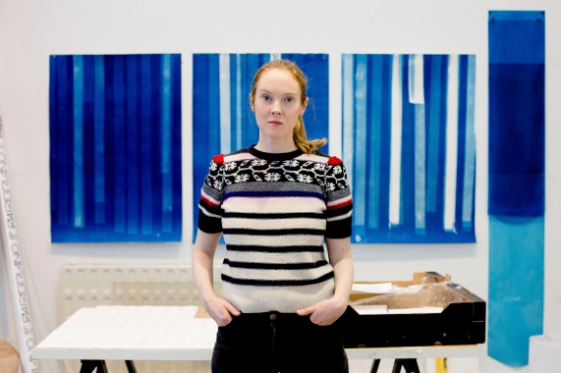

Artist **Caoimhe Kilfeather** was awarded the Per Cent for Art Commission – N25 New Ross By Pass and has been developing the art work on this commission due for completion and installation in early 2020

**Caoimhe** studied at the National College of Art Design, Dublin and the Slade School of Fine Art, London. Her work is predominantly sculptural and often generated through experimental and intuitive processes in the studio alongside more targeted research and reading. The affect and experience of different materials, light conditions and scales is integral to the development of the work - both the context of *being in* architecture and the built environment as well as in landscape and the natural environment.

Recent solo exhibitions include *Elemental* at the West Cork Arts Centre (2019), *season and evening and weather and history* at the Douglas Hyde Gallery, Dublin (2017) and *this attentive place* at Temple Bar Gallery + Studios, Dublin (2014). Her work is included in many national collections such as IMMA, the OPW and the Arts Council.

She lectures in Sculpture and Combined Media at the Limerick School of Art and Design.

**The Artwork**

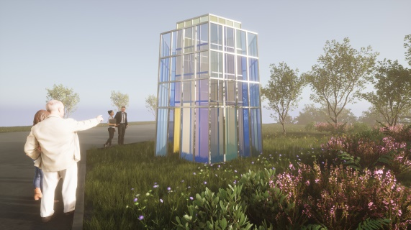

**The N25 New Ross By Pass commission will be situated at The Strokestown Lay by Viewing area overlooking the “Rose Fitzgerald Kennedy” bridge and will comprise of a glass and steel structures loosely referencing the local architectural landmark of the nearby Stokestown House Folly.**

**The coloured glass will reflect the landscape -** the hues and tones of the fields, hedgerows and sky. On overcast days the glass will appear dense and opaque and on bright summers days more transparent - allowing views through to the surrounding landscape. In this way it is envisaged that the sculpture be dynamic and responsive to its site and to the elements.

**At four and half metres in height** the artwork will be a significant and striking element within the landscape of the layby and will be there for the public to enjoy as it overlooks the new Rose Fitzgerald Bridge.

