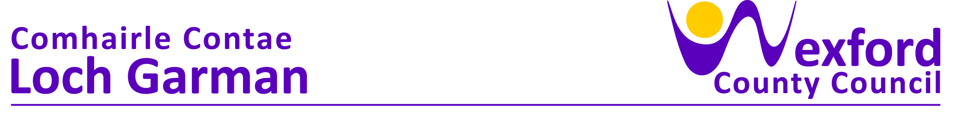

**PRESS RELEASE 02 June 2023**

**Separating food waste is a positive climate action that we can all make –**

**National Food Waste Recycling Week Launched at County Hall**

Councillor George Lawlor, Cathaoirleach of Wexford County Council officially launched National Food Waste Recycling Week at County Hall on Wednesday 31st May. Now in its second year, the National Food Waste Recycling Week will run from the 5th until the 11th June 2023. The campaign is being managed by MyWaste, supported by Local Authorities and funded by the Department of the Environment, Climate and Communications.

Councillor George Lawlor stated ‘The campaign aims to encourage everyone to recycle food waste by providing practical advice along with hints and tips on how easy it is to recycle and get everyone involved. Food waste is a big issue, as wasted food can sometimes end up in landfill where it will produce methane which is a harmful greenhouse gas; this combined with the resources used to get the food to us, the consumers, and then wasting this food can have significant impacts on the environment. The recycling of food waste diverts this important resource from landfill and allows it to be transformed into renewable energy and fertilisers for horticulture and agriculture use in Ireland’.

Cliona Connolly, Environment Section said that ‘This year’s campaign aims to ensure that people understand that food waste needs to be fully separated from all packaging such as plastic or other containers to prevent contamination at the compost and anaerobic digestion facilities leading to higher quality recycling. I would encourage all to attend one of our events during National Food Waste Recycling Week and pick up their free food waste caddy pack’.

Events will be held locally and nationwide to highlight National Food Waste Recycling Week 2023.

Local Events  
Free Food Waste Kitchen Pack Distribution Events at the following locations, on the below dates between 10 am - 12 noon & 1 pm – 3 pm

* Wednesday 7th June - Gorey Household Recycling Centre, Gorey Business Park, Ramstown, Gorey, Y25 KT35
* Thursday 8th June   - Enniscorthy Household Recycling Centre, Kilcannon, Old Dublin Road, Enniscorthy, Y21 KC43
* Friday 9th June - Holmestown Household Recycling Centre, Barntown Wexford, Y35 Y28W
* Saturday 10th June - New Ross Recycling centre, Hewittsland, New Ross, Y34 HT99

At the above events, subject to availability, attendees will receive a food waste caddy, each with a starter pack of caddy liners and an information leaflet.

For more information on the National Food Waste Recycling Week 2023, see [www.mywaste.ie/national-food-waste-recycling-week/](http://www.mywaste.ie/national-food-waste-recycling-week/)

ENDS

Notes to Editor:

Photograph courtesy of Ger Hore

From left: Gerry Forde, Snr Engineer, Environment section WCC , Frank Burke, Climate Action Co-Ordinator WCC, Jonathan Dunne, Department of the Environment, Climate and Communications, Councillor George Lawlor, Cathaoirleach Wexford County Council, Cliona Connolly, Environment Section WCC and Clare Kelly Climate Action Officer, WWCC