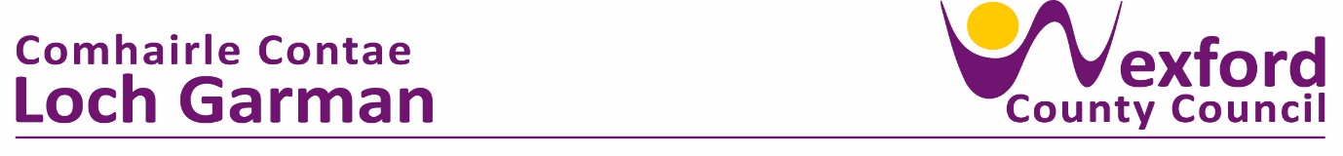**PRESS RELEASE 13th September 2023**

**CULTURE NIGHT RETURNS ON 22nd September**

Culture Night returns across Ireland on Friday, 22 of September and invites everyone to join in, discover and celebrate culture in all its forms. Venues all over the country open their doors, with free events programmed from 4pm till late. Culture Night in County Wexford will be celebrated with a variety of events across all five municipal districts in art centres, community centres, libraries, and public spaces. To see what’s on visit [www.culturenight.ie/wexford](http://www.culturenight.ie/wexford)

Culture Night brings people together to create unique shared experiences, to highlight the quality and diversity of Ireland’s cultural offering, while also introducing audiences to new arts venues and emerging creative talent. All for FREE! Art, music, spoken word, comedy and film are all on the programme and organisers are asking audiences to explore and try something new at this year's event.

A very special event, The Lighthouse Project curated by Dani Gill and funded through the County Wexford Creative Ireland programme, will take place at Hook Head on Culture Night. Local artists Sasha Terfous, Richard Carr and Basciville, have collaborated on a site-specific project at Hook Head that engages with the landscape and history of this iconic place. Audiences will follow Richard’s guided soundscape experience into the lighthouse, culminating in a live performance by Sasha. Three very special tours will be available for audiences on the night.

Culture Night celebrates the diverse range of cultural activity happening in the county and there will be something for everyone to explore at this year’s event. History and heritage enthusiasts can experience guided tours of the 19th century Johnstown Castle, engage with a talk and exhibition hosted by the North Wexford Historical Society at Gorey Market House, join the Bunclody library for a discussion of some of Ireland’s most treasured paintings or chat with a member of the Roche family about life in early 20th century Enniscorthy at Enniscorthy Castle’s Living History event. For those that prefer to get involved in creative activities, there will be plenty for audiences to do and make, with taster workshops happening at the Gorey Art Collective, Gorey School of Art, Caroline Bergin Art, The Makers House and The Printmakers Hub at the Creative Hub Wexford as well as guided sketching at d.central New Ross and live sketching events at the Presentation Arts Centre in Enniscorthy, which includes a very special late night Drag and Draw event.

Culture Night is also an opportunity to highlight the next generation of artists and a range of youth focused events will take place on the night, such as the Youth Cabaret at the Wexford Arts Centre, a poetry slam, spoken word competition for 13 –19 year-olds hosted by Poetry Ireland & Red Books Wexford, a special screening hosted by the County Wexford Youth Film Project in St. Michael’s Theatre of short films by young filmmakers from across the country, a performance of harp music at the Wexford Library by teenage traditional Irish group Cláirshí Neamhaí, a dynamic performance by Music Generation Wexford’s Yellow Bellows singing group at the bandstand in St.Peter’s Square Wexford, and a specially curated selection of music by Music for Wexford Junior Committee at St. Iberius Church.

Access to cultural activities in local communities and villages will also be a key part of this year’s programme. Experience a night of comedy at the Halfway House, Ballycogley, an evening celebrating the songs of the iconic Delia Murphy sung by her niece, Carmen Cullen, at McCalls Centre, Rathangan or attend The Gap Arts Festival event in North Wexford; From Ballythomas to Memphis and Back - Road Trip to the Cradle of the Blues featuring local musician Ashley Hayden.

All events are free, but some will have limited availability and may need booking. Please check the website for times, booking links and event updates.

Culture Night / Oíche Chultúir is brought to you by the Arts Council in partnership with Local Authorities and many other organisations and individuals across the island. For more information on County Wexford Culture Night 2023, visit [www.culturenight.ie/wexford](http://www.culturenight.ie/wexford).

*Join the conversation online at* [*www.facebook.com/CultureNight*](http://www.facebook.com/CultureNight)*,* [*www.twitter.com/CultureNight*](http://www.twitter.com/CultureNight) *and* [*www.instagram.com/CultureNight*](http://www.instagram.com/CultureNight)

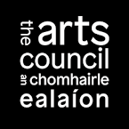**

**ENDS**

**Press Contact: Tamara Gangnus**

**wexfordculturenight@gmail.com**