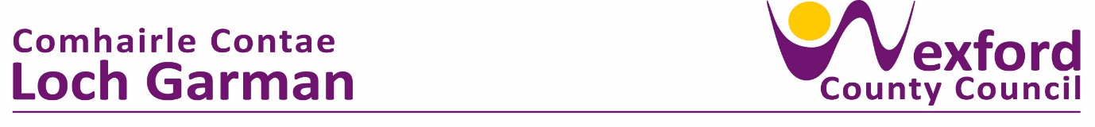 **PRESS RELEASE 15 April 2024**

**ADOPTION OF THE LOCAL ECONOMIC & COMMUNITY PLAN 2024 – 2029**

The elected members of Wexford County Council adopted the LECP Framework Plan 2024 – 2029 and LECP Implementation Plan 2024 – 2025 at the April meeting of Wexford County Council.

The primary aim of the LECP is to set out the objectives and actions needed to promote and support the economic and community development of Co. Wexford. This Plan includes a series of High-Level Goals which represent the specific vision that Wexford County Council wishes to deliver directly or in partnership with its economic and community development stakeholders over the next 6 years.

The development of the LECP has provided an opportunity to frame an ambition for the County and its development over the next number of years, an ambition which is based around the understanding obtained from the research conducted in the development of the LECP and through views provided during the consultation process with key stakeholders, the community and the private sector.

The approval of this plan by the elected members of Council followed consideration by the Local Community Development Committee, Strategic Policy Committee for Economic Development & Enterprise, Municipal Districts and Southern Regional Assembly.

Welcoming the new strategic plan, Cathaoirleach of Wexford County Council, Cllr. John Fleming, highlighted that the LECP and implementation plan provides us with a framework to continue supporting the sustainable growth of our local economy and communities.

Proposing the adoption of this statutory document, Chairperson of the Economic SPC and Advisory Steering Group member, Cllr Michael Whelan said he was delighted to see the completion of the project after an extensive consultation and development process.

Speaking afterwards, Chairperson of the Local Community and Development Committee, Cllr. Aidan Browne, welcomed the adoption by the Members, thanking everyone who contributed to it and looked forward to seeing the delivery of the agreed goals and objectives for County Wexford over the next six years.

Preparations are currently underway for an official launch of the Local Economic & Community Plan (LECP) in the coming weeks.

ENDS