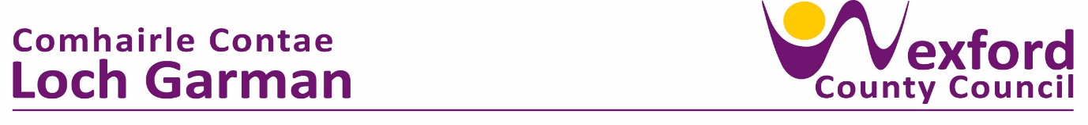

**PRESS RELEASE 15th November 2023**

**Talking Encouraged in Wexford Libraries as Happy to Chat Initiative Extends**

Following the success of the pilot ‘Happy to Chat’ Café initiative rolled out in Summer 2023, the initiative is now to extend with local businesses and organisations encouraged to get involved. In tandem, Wexford Public Libraries are also getting involved, with Happy to Chat cards to be placed on tables in your local library and the monthly library conversation hour at Wexford Town Library to be rebranded as the ‘Happy to Chat’ Conversation Hour.

In any of the Happy to Chat locations people are asked to consider sitting at the chatting table alone or with a friend, highlighting that you are open to others joining you. Within libraries, hotels, restaurants and cafes participating the premises allocate one of their tables as a ‘Happy to Chat’ table, and in each location these tables are identified by a small table sign in the distinctive Healthy Ireland green colour.

The addition of the library Conversation Hour, the Happy to Chat project extends the chatting opportunity further as this is a specific time when people come into the library to chat. In Wexford Library this happens at 11am on the second Tuesday of each month. Speaking at the November Happy to Chat Conversation Hour in Wexford Library Leas Cathaoirleach of Wexford County Council, Cllr Ger Carthy said ‘It’s exciting to see this initiative extend as I know it can be of benefit to reduce loneliness and isolation in a range of locations across County Wexford, from businesses to community cafes and now also in our libraries.’

Chair of the Healthy County Committee, Cllr John Hegarty added ‘It is often the simplest ideas that work best, and I want to acknowledge the work of Cllr. Maura Bell and our Mental Wellbeing Working Group who have developed the initiative, and the pilot locations who have taken it on board and helped us to trial and refine it for further roll out’.

The Wexford ‘Happy to Chat’ initiative commenced during the Covid period with the development of custom ‘Happy to Chat’ benches to increase social engagement & reduce loneliness and isolation in our county. With the ability to safely return indoors the ‘Happy to Chat’ Café initiative was piloted in Summer 2023. Following review and feedback from pilot locations the Healthy Wexford team are continuing and extending the initiative.

**L to R: Mayor of Wexford, Cllr. John Hegarty; Cllr. Maura Bell; Annette Dupuy, Healthy County Coordinator; Cllr. Ger Carthy, Leas Cathaoirleach of Wexford County Council; Hazel Percival, Senior Executive Librarian. (Photo Credit: Rocket Science Media)**

If businesses or community cafes across County Wexford would like to get involved they should get in touch with the Healthy County Coordinator, Annette Dupuy – via Healthy Wexford social media, by email [annette.dupuy@wexfordcoco.ie](mailto:annette.dupuy@wexfordcoco.ie) or by calling 053-9196000. Participating locations will be provided with table tent cards, a window sticker and a short guidance note for rolling out the initiative.

To find out details of the Happy to Chat initiative in libraries, contact your local library.

ENDS