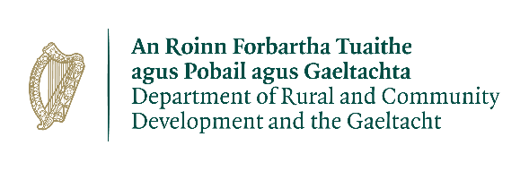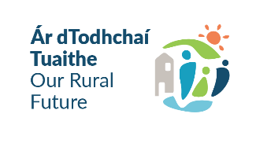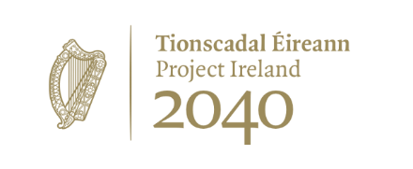
Expression of Interest Form
2026 Town and Village Renewal Scheme
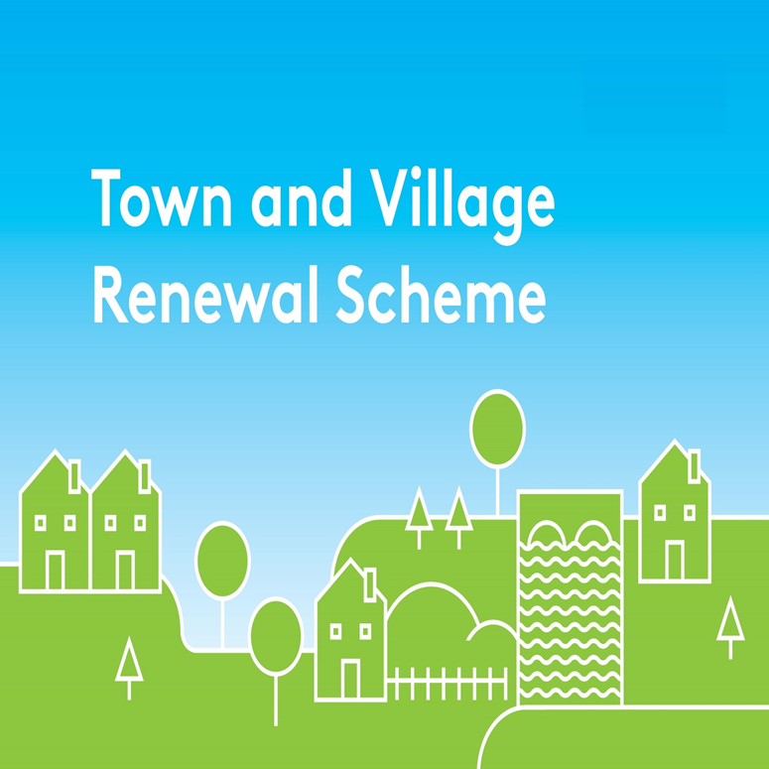
Please complete this Expression of Interest form
and return it to your Local Authority designated contact.

Town and Village Renewal Scheme 2026

Town/Village covered:

Please indicate which category of funding is being applied for:

Category 1 Category 2 Category 3

Towns/Villages with Towns/Villages with Towns/Villages with

Population of 5,000 Population of Population up to

or less 5,001-10,000 15,000

Category 4

Pilot “Urban Towns”Category

Amount of Funding Requested:

Applicant Group:

Applicant Contact Name:

Applicant Contact Address:

Applicant Telephone Number:

Applicant Mobile Number:

Applicant Email Address:

- Has funding for this project ever been sought from other sources? Yes No
(If "YES" yes please specify from what source and if funding was provided)

- Who are the specific project stakeholders/community partners in this project?
(Chamber of Commerce, Community group, etc.).

- Project details:
- If seeking funding of between €300,001 and €500,000, please detail the particular case for this level of funding.

- What is the objective of the proposed project and how will the intended outcomes be measured? (Please identify any metrics or benchmarks that will be applied).

6.Match Funding
Is the full match funding in place at the time of this EOI (Y/N)? If no please provide further detail
Source(s) of Match Funding:
Please provide details

DECLARATION
I hereby confirm that I have read and understand this document. I request that consideration be given in support of the project as outlined above.

Signature __________________________________________________

Position __________________________________________________

Date __________________________________________________

Please return completed EOI in both WORD and signed PDF format to tvr@wexfordcoco.ie by 5.00p.m on Wed 4th Nov, 2026

