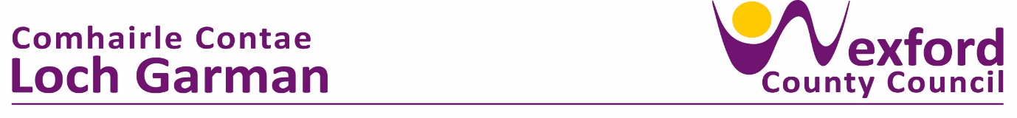

**PRESS RELEASE 22 April 2024**

**Excellence in Service to the Community and Sporting Achievements acknowledged at Civic Reception.**

Over 200 local people attended a Civic Reception held by New Ross Municipal District in the Brandon House Hotel on Thursday last, 18th April 2024.

The ceremony honoured a total of 18 individuals / groups from the district previously nominated and endorsed by the members of New Ross Municipal District.

Presentations of a framed, newly commissioned, bronze piece depicting the New Ross crest were made by the New Ross Councillors to each recipient.

Speaking at the event, Cathaoirleach of New Ross Municipal District, Cllr Anthony Connick, said ‘it is a fantastic opportunity to showcase and recognise excellence in sporting achievements of the sportsmen and sportswomen of the district, whilst it is also fitting to express gratitude and appreciation of the vast number of superb volunteers and community groups for their tireless efforts in serving their communities.

The full list of the recipients honoured with a Civic Award are:

**Excellence in Sport:**

New Ross Rugby Club – Ladies Team

New Ross Boat Club

Sean Lyng

Ballycullane Ploughing Association

Gusserane Ladies Football Team

Michael (Mikey) Kent

Geraldine O’Hanrahans GAA Club – Poc Fada Winners

Derek Roche

New Ross Rugby Club – Junior Team (u16 boys)

Kai Butler

Evan Bailey

Denny Bookle

**Excellence in Service to the Community:**

Alan Bailey

Rathnure Pantomime Society

Cloughbawn FC

Clonroche Poulpeasty Meals on Wheels

Rathgarogue Community Cooperative Society

Courtnacuddy Development Group

ENDS