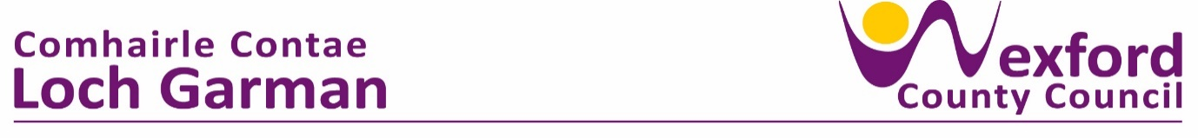
Press Release 22 March 2024

Small Arts Festival & Fáilte Ireland Festival Grant Scheme 2024

Wexford County Council is pleased to announce that 20 Festivals throughout the County have been award funding in 2024 through the Arts Office Small Arts Festival Fund and Fáilte Ireland Festival Scheme. This amounts to a total investment of €50,000 in our local communities. This year the Grant Scheme was broken into 2 strands:

Strand 1 – Small Arts Festival Grant Total Fund €25,000 : This grant supports a diverse range of small arts festivals or experimental artistic events throughout Wexford County. The focus is on festivals of artistic quality and have a strong emphasis on public engagement. We also welcome applications promoting cross disciplinary artistic collaborations and experimentation.
Strand 2 – Fáilte Ireland Festival Grant Total Fund €25,000 : This strand supported by Fáilte Ireland aims to support festivals that drive domestic tourism, help to improve the visitor experience in County Wexford, focusing on historic festivals, traditional culture festivals and festivals promoting food culture.
A total of 20 festivals were awarded funding of between €1,000 - €3,000 each, out of a total of 37 applications.
Small Arts Festival Awarded festivals 2024.
- The Gap Arts Festival 2024 - A full weekend to celebrate, enjoy, and discover new perspectives, offering engagements with art/artists, innovative performances and participative workshops, GAF has developed collaborations between artists and community telling our own stories in this landscape.
- The Gorey May Bush Féile 2024 - A programme of community engagement events starting in April 2024 and culminating in the annual & final community performance/participatory event on May Eve 2024 in Gorey District.
- Flow Youth Dance Festival - a two-day festival of dance workshops and a live dance performance in New Ross aimed at young people.
- New Ross Guitar Festival – a festival showcasing the best of local, national and international guitarists, includes concerts, workshops and various busking events in various locations in New Ross.
- FuddleFest - presents a multi-genre music festival with an emphasis on high quality contemporary music performances over 2 days indoors and outdoors in the rural environment of Fuddletown Farm, Killinick.
- Jazz at Johnstown - Offering three days of jazz music playing across multiple stages in addition to indoor evening concerts at Johnstown Castle.
- ‘Write By The Sea’ Literary Festival – is an annual literature festival that brings a hive of literary activity into Kilmore Quay, by presenting readings, interviews, discussions, storytelling and workshops with international, national and local writers.
- ‘SpringMoves’ Dance Festival – In partnership with the National opera House. A 2-day festival celebrating dance for children and adults alike with invited local, national and international dancers. Includes workshops, street dance performances and talks.
- One Voice Festival: Wexford Reflections 1974-2024 – A festival celebrating new playwrighting voices in Wexford, culminating in 8 short monologue plays, performed over a series of evenings in Wexford Arts Centre
- The Wexford May Bush Festival 2024 – online and in person arts festival celebrating the May Bush with events from mid-April to mid-May.

- Coolcatts Halloween Fest 2024 – A festival of music, magic, opera and extreme rhythm for young people in Wexford town.

Fáilte Ireland Awarded Festivals 2024
- Rockin’ Food & Fruit Festival Enniscorthy - a fun filled weekend for families, Rock ‘n’ Roll enthusiasts, foodies and lovers of Irish Craft in Enniscorthy.
- Leo Carthy Weekend – this two-day festival incorporates a wide range of entertainment that caters for all age groups with live music across many musical genres, plays, story-telling and art workshops.
- Rosslare Harbour Festival 2024 – a festival that is a series of community lead events that explores the rich heritage of the village, port, surrounding areas and the relationship with the wider world.
- North Wexford Traditional Singing Féile – a weekend of traditional song workshops, singing events, and singing & historical walking tours.

- The Eugene O’Neill International Festival of Theatre – a festival celebrating the unique historic legacies of actor James O’Neill and his son, the celebrated playwright Eugene O’Neill, in their ancestral home area of New Ross, Co Wexford.

- Blackstairs Blues Festival 24 - a three-day festival of Blues events, workshops and live performances in Enniscorthy.

- Festival of Ferns - a 2 day annual festival celebrating Ferns heritage and culture. There will be a colourful carnival type parade and celebratory re-enactment when a new King of Leinster (previously ruled from Ferns) will be crowned - alongside a variety of fringe events.

- Kilanerin Food & Heritage Festival - a festival including an artisan food market, exhibiting locally produced food, alongside two days of food demonstrations from local chefs, food experts and producers in north Wexford.

- Rebellion Day &1798 Summer School - A municipal commemoration to recognise the anniversary of the Longest Day in 1798 and Summer School with a programme of special guest lectures and guided tours at the National 1798 Rebellion Centre, Enniscorthy Castle and Vinegar Hill focused on the events of 1798.

Liz Burns, County Arts Officer, Arts Department, said, ‘Wexford County Council is delighted to support twenty unique festivals in 2024, that each celebrate Wexford’s vibrant arts and cultural heritage for locals and visitors to enjoy. I wish all the festivals every success in 2024 and look forward to attending them”.


ENDS
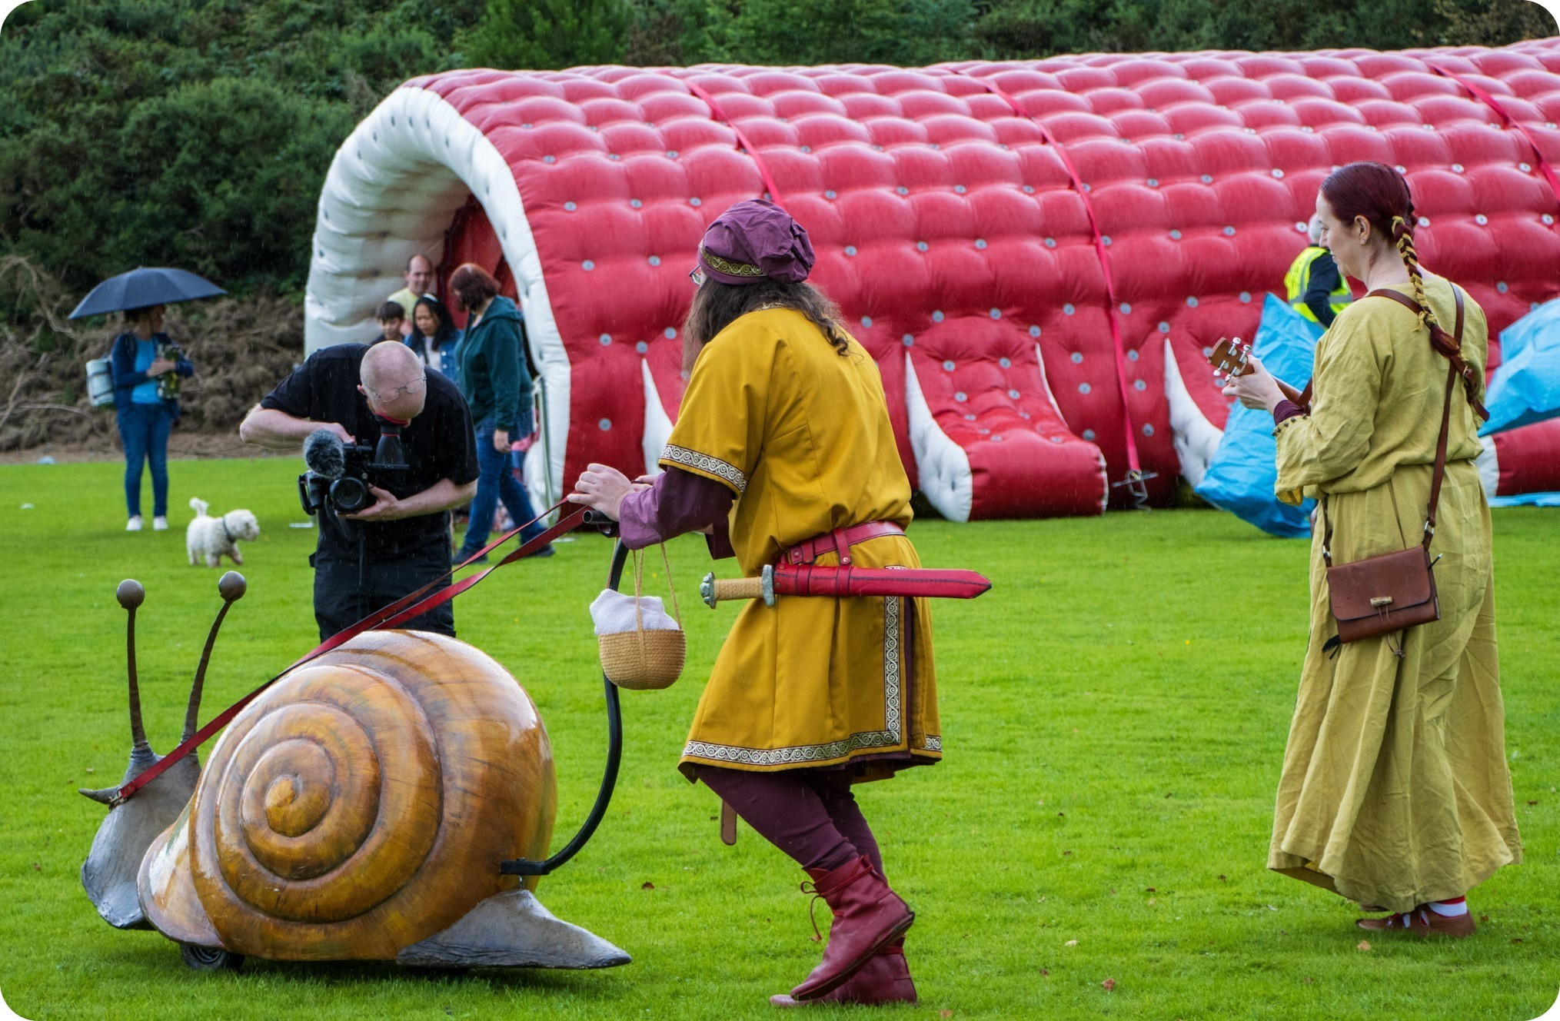
Small Arts Festival Awardee 2023 – At The Picnic@TheGap. Filming the Snail. (Photo Keely Redmond)
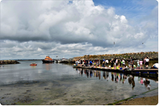
Image 2: Failte Ireland Festival Awardee 2023 – Rosslare Harbour Festival 2023 (Photo by Larry Dunne)

