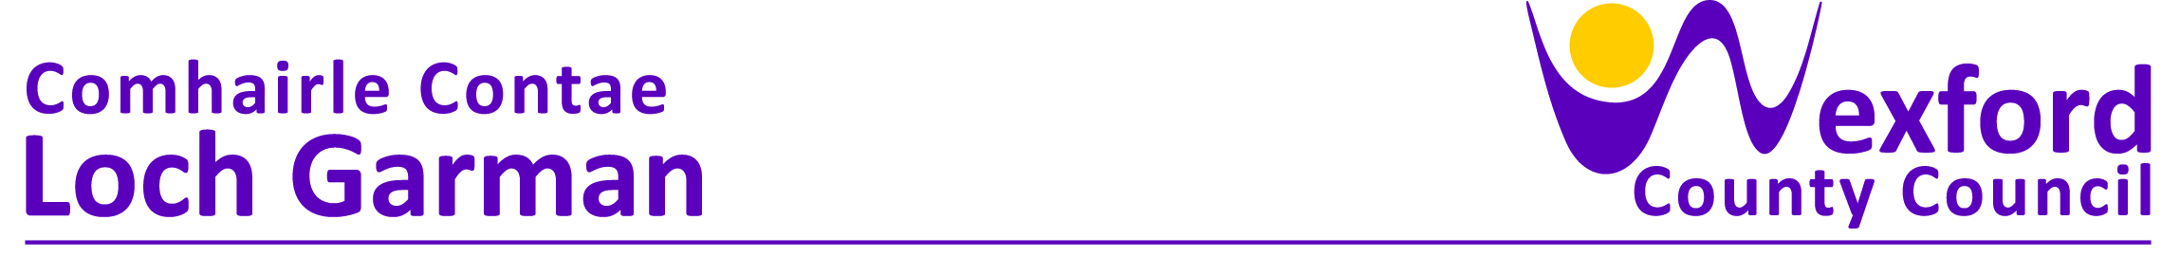

PRESS RELEASE 23 June 2023

KEEP WEXFORD BEAUTIFUL COMPETITION 2023

The 2023 Keep Wexford Beautiful Competition is now welcoming entries following the launch of the competition by An Cathaoirleach, Councillor George Lawlor. Councillor Lawlor said ‘this competition encourages people to think and act locally on a range of environmental issues such as waste prevention, accessibility, biodiversity and heritage preservation. It encourages everyone to get involved in their local community. The competition is about recognising the huge voluntary work that is carried out by all voluntary groups and individuals who take action, large or small, to improve their local environment.’

You can now submit your application on-line by logging onto www.wexfordcoco.ie/keepwexfordbeautiful or application forms are available from the Environment Section, Wexford County Council, Carricklawn, Wexford. Closing date for receipt of all applications is Friday 30th June 2023.

The success of the Keep Wexford Beautiful Campaign depends on community involvement. Winners of the competition will be awarded at the Annual Environment Awards Ceremony to be held in November. The overall winner in 2022 was Enniscorthy Community Allotments.

The Categories are:
- Best Environmentally Aware and Presented Housing Estate
- Best Environmentally Aware and Presented Town or Village
- Best Community Environment Initiative
- Best Heritage, Preservation and Conservation Project
- Best Community Coastal Management Initiative
- Best New Group Entry (group new to this competition)
- Best Community Project to Improve Accessibility in Gardens/Parks.
- Best Community Project to Improve Accessibility to Infrastructure.
- Best Community Biodiversity Project
- Best Community Project that Tackles and Reduces the Impacts of Climate Change
- Best Community Waste Prevention / Reuse Project

Further information is available at www.wexfordcoco.ie/keepwexfordbeautiful or by contacting the Environment Section at 053 9196684.

ENDS

