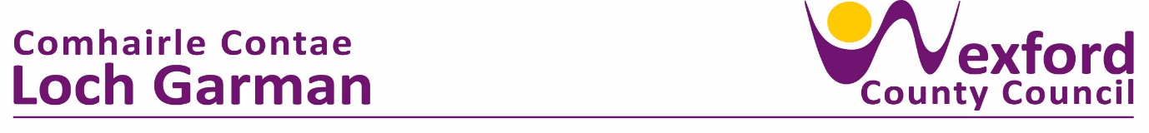

**PRESS RELEASE 26 April 2024**

**Minister of State Jack Chambers, visits Rosslare school to mark completion of ‘Safe Routes to Scheme’ works.**

Scoil Mhuire National School Rosslare hosted Minister of State, Jack Chambers to mark completion of upgrade works outside the school under the Safe Routes to School Scheme on Monday 22nd April. The fabulous weather allowed the ceremony to take place outside and all the pupils were delighted to be part of proceedings. Minister Chambers mingled with staff and students alike to discuss the scheme and welcome the upgrade works.

Cllr John Fleming, Cathaoirleach of Wexford County Council hosted the event, attended by Minister of State, James Browne, Cllr. Jim Moore, Cllr. Ger Carthy, Cllr. Lisa McDonald, Cllr. Jim Codd & Cllr. Frank Staples alongside representatives from the NTA, An-Taisce and Green Schools.

Cllr. Fleming thanked the Elected Members and school principal, Bobby Kenny for their support of the scheme which ‘has seen installation of footpaths and pedestrian crossings surrounding the school to allow students, parents & buggies walk and wheel to school. Cllr. Fleming remarked that ‘It’s easy to forget that only a few months ago there were no footpaths in front of the school. Today there are children running outside, parents in conversation and reduced congestion outside the school. In addition, 250m of new footpath overlooking the sea on the Coast Road linking to Mauritiustown where many students here today travel from.’

School Principal, Bobby Kenny thanked all involved saying “we are thrilled to unveil these fantastic upgrades. This project has transformed the way our students arrive at school.

Previously, parked cars on footpaths created a dangerous situation and restricted access for everyone, especially young children, parents with buggies, and wheelchair users. Today the attractive new lighting and landscaping elements not only enhance safety but also create a more cheerful and welcoming approach to the school.”

“Minister Chambers outlined that the Safe Routes to School Scheme is for the safety of children and parents. He described Wexford County Council as one of the top performers nationally in implementing the scheme having completed Round 1 of Wexford schools. Minister Chambers is also looking forward to Round 2 SRTS projects as part of the €3.75m Active Travel allocation for 2024.”

The Safe Routes to School Scheme is a national programme to improve safety at school gates, increase walking and cycling and alleviate congestion in front of schools.

The Active Travel Team in Wexford County Council designed and supervised the project with works completed appointed contractor Paddy McGee Ltd.

The project had an initial allocation of €80,000 in 2023. This was increased upon application by Wexford County Council to the NTA to €302,000.

ENDS

