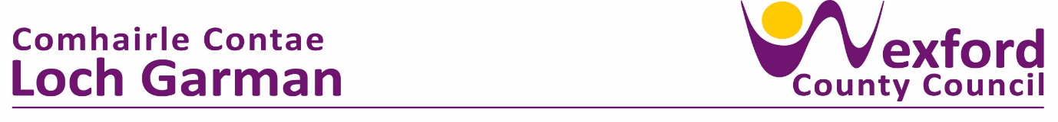

**PRESS RELEASE 27 Sept 2023**

**NEW BRAND AMBASSADOR, LOUISE CANTILLON, ENCOURAGES WEXFORD STUDENTS TO SIGN-UP FOR IRELAND’S TOP TEEN ENTERPRISE PROGRAMME**

Schools across County Wexford are being encouraged to sign-up for this year’s Student Enterprise Programme (SEP) by new Brand Ambassador and rising Irish media star, Louise Cantillon.

A Limerick native and former second level schoolteacher herself, Louise will be encouraging the thousands of participating students this year as they embark on their exciting entrepreneurial journey, creating, setting up and running their own business to compete for the top prize of Student Enterprise of the Year

County Wexford has had significant success at National Level over the years. Last May, students from Ramsgrange Community School Alison Duffin and Amy Duffin (**Positive Pots**) received the Special Merit Award in the Intermediate category.

*Head of Enterprise at LEO Wexford, Breege Cosgrave says “Participation in the Student Enterprise Programme provides students with a unique opportunity to develop entrepreneurial skills from researching an idea, turning that idea into a business and ultimately bringing a product or service to market. Learnings from the programme and the skills developed are critical to supporting a culture of entrepreneurship which underpins our local economy. Last year we had over 1,100 Students in Wexford participating in the programme which is a testament to the significant support of dedicated teachers in all the schools across the county. We are looking forward to supporting this year’s group of students explore what it is like to run a mini business and develop skills along the way.*

An initiative of the Local Enterprise Offices of Ireland, the Student Enterprise Programme is the country’s largest enterprise programme for second level students, with this year marking the 22nd year of the hugely successful programme. Over 25,000 students from approximately 500 second level schools across the country are expected to take part.

Students from 1st year to 6th year can enter in the Junior, Intermediate and Senior categories. Participants will learn how to create and run their own business, picking up key skills along the way such as ideation, marketing, finance and sales.

The Programme is run through the network of Local Enterprise Offices, supported by Enterprise Ireland and the local authorities, with local coordinators in every area to support teachers and students through the year of the programme, which helps foster entrepreneurship in students and gives them key skills they can bring with them into later life.

New Ambassador Louise Cantillon is delighted to be partnering with the Student Enterprise Programme for 2023/24 and is looking forward to engaging with the community of teen entrepreneurs to encourage them on their exciting business journey.

Louise says she is particularly excited about the roll-out of the new student workbooks as Gaeilge this year, *“I am so excited to be working on the SEP project and learning about all the fantastic businesses these young students are going to be working on this year. The fact that the student workbooks are also being published as Gaeilge this year with thanks to the Irish language agency COGG is fantastic and a great resource for all the gaelscoileanna around the country”.*

Last year the winners were *MC Compactors* from Roscommon in the Senior Category with their business idea - an innovative stainless-steel rubbish compactor. In the Intermediate category the winner was *Clip Clop Designs* – a company that upcycled used horseshoes into household ornaments. The Junior category was won by a group of Leitrim students with their student enterprise *Grasper -* a lift mechanism to open slatted tank covers on farms*.*

Since the Student Enterprise Programme began in 2003, over 325,000 students have taken part, learning key skills on how to create a business idea, start a business and grow a business.

The Student Enterprise Programme also has a new range of online resources for 2023/2024 at [www.StudentEnterprise.ie](http://www.studententerprise.ie/), which will feature regular blogs and houses a full range of Student Enterprise resources for students and teachers.

ENDS

**FOR FURTHER INFORMATION CONTACT:**

**Annette Rowsome**

**Senior Enterprise Development Officer**

**Local Enteprise Office, Wexford**

**Tel 059 9196620 087 3813449**

**Email:** [**annette.rowsome@wexfordcoco.ie**](mailto:annette.rowsome@wexfordcoco.ie)

**Website:** [**www.studententerprise.ie**](http://www.studententerprise.ie)