
PRESS RELEASE 6th February 2024

Investment in ‘McCauley Bellfield Park’ highlighted at Enniscorthy sod turning.

Rapparees Starlight’s GAA Club and Wexford County Council, Enniscorthy Municipal District held a sod turning event at Bellefield GAA grounds this week to celebrate a significant private-public-community investment programme that will transform the community and sporting facilities on offer.

An ambitious four-phase project will see investment in new facilities for the community of Enniscorthy over the coming years. The vision is to create a ‘Flagship Sports and Community Facility’ at world class standards in the heart of Enniscorthy, promoting the health and wellbeing of the wider community in a safe and inclusive environment.

The overall project will see investment of over €1.5 million, with collaboration from the local community and the Rapparees Starlight’s Finance Committee raising four hundred thousand euros; Wexford County Council providing funds of four hundred thousand euros and a greatly appreciated donation from Mr Sam McCauley of six hundred thousand euros.

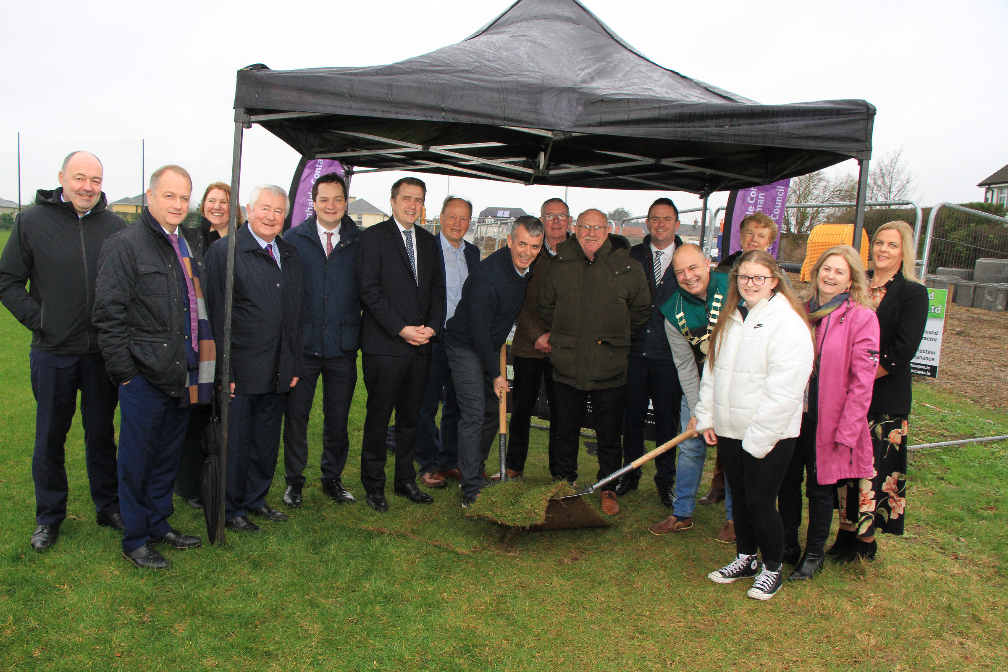

Ger Mc Veigh (Chairman Raparees Starlights GAA Club & Cllr. John O’Rourke (Cathaoirleach Enniscorthy Municipal District) turning the sod of the Building Bellefield Project

The first phase, which is approaching completion, included the development of two new pitches, fencing and associated drainage works, main infrastructure for a sensory garden as well as a community walking track complete with lighting. Major ESB works were required with the removal of six poles and cables brought underground to a newly installed ESB pillar station. Funding for this phase was provided by philanthropic donation from local businessman and long-time club member, Mr. Sam McCauley which also saw the Park being renamed, McCauley Bellefield Park.
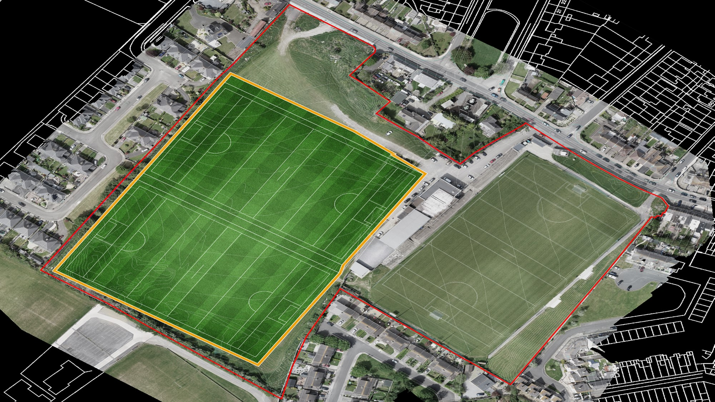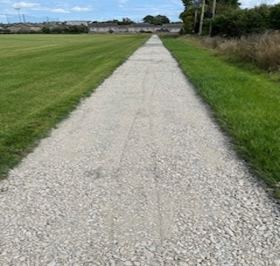

The second phase of the project, which is commencing February 2024, is a public-community partnership and will include the development of a new statement entrance for the Club, together with 25 new public carparking spaces, new footpath with bollards, fencing, public lighting and signage. A new pedestrian crossing on the Bellefield Road will be delivered as part of phase two, as well as a new pocket garden with seating and a playground for young children. Funding for this second phase will be from the Rapparees Starlight’s Club in association with Wexford County Council.

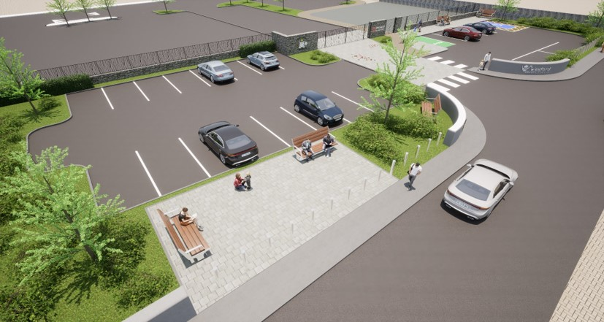

Opening the event, the chairperson of Rapparees Starlight’s GAA Club, Mr Ger McVeigh welcomed guests including Cathaoirleach of Enniscorthy Municipal District, Cllr John O’Rourke and the elected members, Oireachtas Member, Minister James Browne, CE Tom Enright, project team members and council officials to the facility to officially celebrate the ambitious programme and in particular to mark the commencement of works under phase two.

The Chairperson welcome speakers from both Rapparees Starlight’s GAA and Enniscorthy Municipal District. Addressing the guests Councillor John O’Rourke, Chairman of Enniscorthy Municipal District welcomed the project stating, ‘this is an exciting development for Enniscorthy. The project is a testament to collaboration, innovation, and the dedication of everyone involved. As we turn the sod in the soil, let it be a symbol of shared determination to create an inclusive community space that will benefit generations to come’.

Mr. Sam McCauley, local entrepreneur, and business owner reflected on his long association with the club, commended the project team for the trojan work, stating ‘the proposed development of the front entrance will be effectively a shop window to the rest of the clubs’ facilities.’ The project manager, Mr. Pat Quigley said, ‘this element of the development is in partnership with the Rapparees Starlight’s Club and Wexford County Council and will provide a state-of-the-art facility in the heart of Enniscorthy that promotes the health and well-being of the whole community.’

Chief Executive of Wexford County Council Tom Enright spoke of the long-term benefit that the new facilities will bring to Enniscorthy, stating, “Wexford County Council is pleased to be part of this wonderful project that will bring real, long-term health and wellbeing benefits to the wider town of Enniscorthy. These new facilities are a testament to the added value that can be brought to a project when private, public and community investment is aligned and coordinated. I wish to thank the Chairperson of the Rapparees Starlight’s and the Club for embarking on such an ambitious project and to particularly recognise the very generous contribution of Sam McCauley, which made this project a reality. Wexford County Councils contribution is focused on realigning and reimagining the entrance to this facility from the public road - by significantly enhancing the safety of the approach and entry/exit of the facility through a new pedestrian crossing and off-street public car parking we will transform the Bellfield Road area. The Council will also support the development of the new playground via the Department of Rural & Community Developments Community Recognition Fund, which we will formally announce soon. “

It is anticipated that the works for Phases 1 & 2 will complete by Summer 2024.

The proposed Phase 3 will see further improvements in the sporting facilities on offer, with an artificial playing surface, hurling wall and lighting planned. The club will seek funding for this phase via the Sports Capital Program through the Department of Tourism, Culture Arts, Gaeltacht, Sport and Media.
The final phase of the project will be focused on activation and animation – generating events and activities to attract members of the community to use the facilities and bring the health and wellbeing benefits to fruition.

Ends

