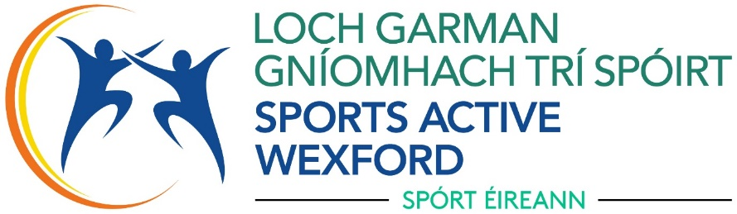

Sports Active Wexford is committed to making our website accessible for all users, especially any persons with a disability. We are working towards having a website that aligns with the National Disability Authorities guidelines and the European Accessibility Act (EAA).

Our Commitment
We are committed to making our website accessible by the following actions:
- Ensuring out website adhers to Web Contact Accessibility Guidelines 2.1 AA standards
- Ensuring our content is operable and understandable
- Reviewing regularly and updating accessibility features where possible

Current accessibility Features
- “Recite Me” is an accessibility solution which we use and is designed to make websites more accessible and user-friendly for people with disabilities. It provides a range of customisable tools that help users navigate, read, and interact with web content more effectively
- Alt text used on most images
- Screen Reader compatibility
- Ongoing upgrades

We strive to continue to improve our accessibility features, but we are aware that some documents may not comply with the required standard. We are continuously working on this.

If you have any difficulties or questions regarding our website, please contact us on sports.active@wexfordcoco.ie or phone 053 9196557

Signed: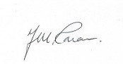 Position: Head of Local Sports Partnership
Date: 25/08/25



