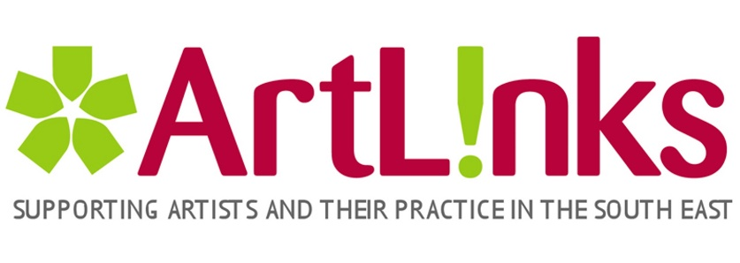
MEMBERSHIP REGISTRATION FORM

Account Details
User name | (lowercase only, no spaces)
Email
Password
Profile Details

Name
Address
County
Phone
Short overview of practice:
Discipline
Social Media/ website URL:
Type of Artist | ☐Professional ☐Emerging

Professional Artists - Membership Criteria
ArtLinks defines Professional Artists as those making their living from their arts practice. To qualify as a Professional Member, you must meet a minimum of three of the following criteria: (Please tick those applicable)
☐Have been in receipt of an award from the Arts Council / Arts Council Northern Ireland or other funding body
☐Hold a Degree or Diploma in a relevant discipline from a recognised third level college
☐Have been awarded a Bursary, a grant or Mentoring through ArtLinks or another similarly recognised body, i.e. Local Authority Arts Office
☐Hold tax-exemption status from the Revenue Commissioners
☐Have had work purchased / commissioned by Government, local authority, museum or corporate client
☐Have held a one-person exhibition (in the case of visual artists) in a recognised gallery or exhibition space
☐Participated in a professional performance event (in the case of the performing arts / dance / music) in a recognised venue
☐Have had a piece of work published / produced (in the case of playwright / writer / poet / songwriter) by a recognised publishing house / production company
☐Have had a piece of work published / produced (in the case of film scripting or film production) by a recognised production company
☐Participated in an exhibition/ event / competition selected by a jury

Emerging Artists - Membership Criteria
ArtLinks defines Emerging Artists who aspire to make their living from their practice. To qualify as an Emerging Artist, you must meet a minimum of two of the following criteria: (Please tick those applicable)
☐Are currently undertaking a Degree or Diploma in a relevant discipline from a recognised third level college
☐Have been awarded a Bursary, a grant or Mentoring through ArtLinks or another similarly recognised body, i.e. Local Authority Arts Office
☐Hold tax-exemption status from the Revenue Commissioners
☐Have held a one-person exhibition or participated in a group exhibition (in the case of visual artists) in a recognised gallery or exhibition space
☐Participated in a professional performance event (in the case of the performing arts / dance / music) in a recognised venue
☐Have had a piece of work published / produced (in the case of playwright / writer / poet / songwriter) by a recognised publishing house / production company
☐Have had a piece of work published / produced (in the case of film scripting or film production) by a recognised production company
☐Participated in an exhibition/ event / competition selected by a jury
☐Have been in receipt of an award from the Arts Council / Arts Council of Northern Ireland or other funding body

