Wexford County Council & Creative Ireland

CREATIVE COMMUNITIES PROGRAMME - APPLICATION PACK 2018

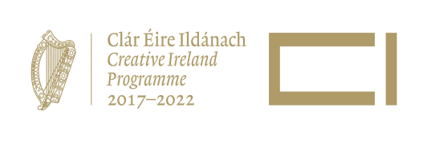
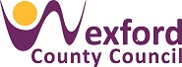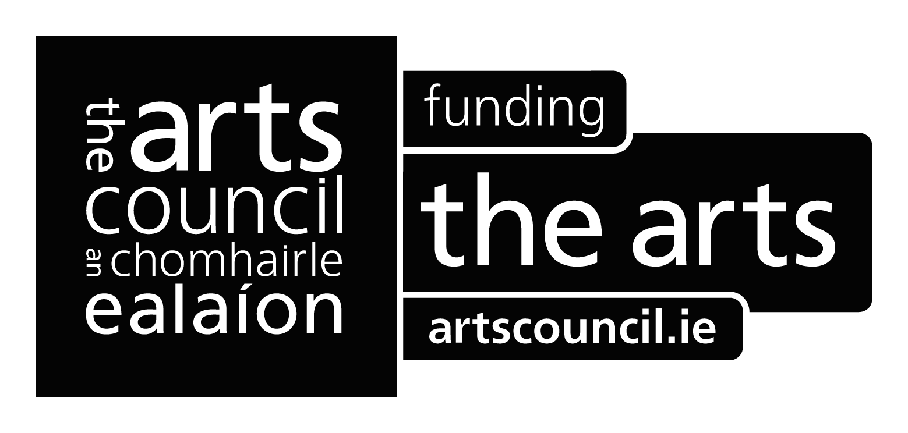

GUIDELINES FOR APPLICANTS

The Creative Communities Programme is open to all community groups that are members of Wexford Public Participation Network (WPPN) and are planning an arts project from 1 intensive week to 5 months in duration (projects must be completed by 30th November 2018); the maximum award is €3,000 in match-funding.

The Arts Department has composed a panel of skilled professional artists who work in a variety of art-forms. This could include film, music, visual arts, theatre, dance, literature, architecture, opera, animation , performance, circus, traditional arts film, music ,drama, visual arts, , literature, dance etc. Any artists from the panel may approach a community group with a view to making an application equally a community group may approach an artist from the panel. You can access the profile of each of the artists from the panel by visiting our website at https://www.wexfordcoco.ie/arts-and-culture.

Applicants must bear in mind that the process of producing art is as important as the outcome. Each project should aim to achieve the following:

- The artistic capacity of participants will be developed as they explore their creativity and learn new skills;

- The group itself will develop, as participants collaborate, interact and exchange ideas with others

General Purpose of the Scheme

Participation, access and social inclusion are central to the services of the Arts Department of Wexford County Council. As a consequence, participants in arts activity explore their creativity, interact and exchange ideas with others, while learning new skills. The Creative Communities Programme is a key tool in addressing this strategic objective.

How much funding is available per project?

Wexford County Council in partnership with Creative Ireland may provide 50% funding, up to a maximum of €3,000 per project. The remaining 50% cost must be matched by community groups.

Please return 3 hard copies of the completed application with 1 hard copy of support material to:

The Arts Department, Wexford County Council, Carricklawn, Wexford.

Deadline: Thursday 12th April 2018 on or before 4.00pm.

Criteria for Assessment:

- Extent of Collaboration – Working together to achieve an outcome. Artists and participants should have a direct influence on the process and product, from start to finish; Strong collaborative projects will be prioritised over traditional teaching models (e.g. art classes)

- Artistic Outcomes – the process should result in an artistic project or event

- Artistic Merit – the depth and quality of the artistic interaction

- Value for Money – clear, realistic budget breakdown

- Proof of Child Protection Policy and Vulnerable Adult Protection Policy, where appropriate – one hard copy of the policy must be supplied with the application

- Proof of membership to Wexford Public Participation Network (WPPN). For further information on applying to become a member of the WPPN visit: https://www.wexfordcoco.ie/community/public-participation-network-ppn

The Assessment Panel will also consider the following:

- Priority will be given to new applicants
- Geographic spread of all submissions
- Number of participants
- Availability of appropriate facilities (e.g. storage, heated room, toilet facilities, running hot and cold water) and management (committee, chairperson, caretaker)
- Evidence of additional funding from other sources
- A history of insufficient final documentation which resulted in cancellation of previous outstanding amounts awarded
- Any history in delay of submitting final reports
- Whether the group has received other funding through Wexford County Council Arts Office.

This is a competitive fund and the amount of money allocated is limited.

If you have a query about any aspect of the application, contact arts@wexfordcoco.ie for clarification.

Assessment Process:
A pool of potential assessment panel members is agreed with the Arts Department in advance. It includes arts practitioners, arts managers, curators, producers and development officers with appropriate community experience and local knowledge, to ensure a balance of perspectives and expertise. A complete copy of each application is forwarded to panel members. The Assessment Panel meets to consider the applications and to shortlist and recommend award recipients.

This award will not fund:

- Applications will not be accepted from schools. Schools can apply to the Arts Department “Living Art Project” for arts project support

- A community group may not apply for more than one project per annum

- Capital purchases are not covered by this funding scheme

Documentation and evaluation:

Projects supported under the Creative Communities Programme must be documented throughout the life of the project. In the final report submitted it must include the following:

- A short written report detailing how the grant aid from Wexford County Council was spent i.e. project details, cost, timeframe, match-funding, outcomes.

- Please include a visual record of the main stages of elements and an electronic version of visual record – (the images should be 300dpi, with a size of 292 x 195mm and saved as a JPEG).

- An evaluation. It is important that this is an honest report which includes a reflection on how participants, artists, co-ordinating organisation or community group found the project.

- Treasurer’s Report and Proof of Expenditure i.e. paid invoices to the value of the grant which is relevant to your application.

- Evidence of your recognition of Wexford County Council’s and Creative Irelands financial contribution to the project e.g. local newspaper articles, advertisements, reports, promotion material, etc. If a permanent artwork is created the Arts Department of Wexford County Council in partnership with Creative Ireland should be credited beside the permanent work.

Checklist for applications:

- All sections of the application form are completed

- The budget clearly indicates the amount sought

- All necessary supporting material is included

- The application is signed by both parties

Terms and Conditions:

Projects must support Wexford County Council’s policy of social inclusion and accessibility.

Funding will be awarded directly to community groups. The community group is responsible for directly contracting and paying the artist.

Funding may be withheld at Wexford County Council’s discretion.

If a launch or celebration is organised as part of the project, the Arts Department must be notified in advance and invited to attend.

Wexford County Councils and Creative Ireland logos must be included in all PR invites If successful in funding the Arts office will email you both logos for your files.

Wexford County Council and Creative Ireland must receive accreditation i.e. “supported by Wexford County Council in partnership with Creative Ireland” on invitations, final artistic output etc.

Community groups must comply with best practice / legislation in Child Protection as outlined by the Department of Health and Children – www.dohc.ie

The community group / host organisation agrees to adhere to Health and Safety legislation and implementing associated requirements.

Should any project be incomplete by 30th November the community group / host organisation must apply for an extension by contacting the County Arts Officer.

With regard to electronic outputs, all rights are transferred to Wexford County Council and perpetual unlimited licence rights are held by the creator.

Incomplete, late, faxed or emailed submissions will not be accepted.

Wexford County Council is co-ordinating the administration for this contract. As such Wexford County Council undertakes to use its best endeavours to hold confidential any information provided by you in this submission subject to the Council’s obligations under law including the Freedom of Information Acts 1997 and 2003. If you consider that any of the information supplied by you in this submission should not be disclosed because of its sensitivity, you should, when providing this information, identify the same and specify reasons for its sensitivity. Wexford County Council will consult with you about this sensitive information before making any decision on any Freedom of Information request received. In the event of a decision to release particular information provided by you, you will have the option of appealing the Council’s decision to the Information Commissioner. Please note that unless information is identified by you as sensitive, with supporting reasons, then it is likely to be released in response to a request under the Freedom of Information Acts.

Submission of the application form implies the community group / host organisation acceptance of the terms and conditions outlined.

Deadline: Thursday 12th April 2018 on or before 4.00pm.

APPLICATION GUIDELINES

It is recommended that you work from a written project proposal in order to complete the application form.

SECTION 1 – The Applicant

This should be the participant community group or host organisation and not the artist.

The artist’s name should be included where requested.

Organisations planning projects for participants who are children, young people and/or vulnerable adults should be aware of the national policy and guidelines in this area.

SECTION 2 – The Project

- Aims/objectives of project

When writing the aims of the project, you should answer the question “what do you want this project to achieve?” It is important that you check that this fits the assessment criteria of the scheme. When setting objectives, ensure that they are specific, measurable, realistic, agreed and given a timeframe.

- Project description

Give a clear description of the project that includes:

- What the project is about and why it is being proposed
- A description of the intended process of the project
- A description of the participants – include age group, gender and numbers
- The duration of the project and contact hours between the artist and the group
- The intended outputs (e.g. exhibition of artworks, theatre performance, parade, book, video, film, concert etc) and outcomes (benefits for the participants, audiences, broader community and other stakeholders)
- Details of your publicity plan – avenues of publicity, target audience, etc.
- Monitoring and evaluation plans to check the project’s activities, progress and performance towards the project’s objectives, schedule, budget and quality

SECTION 3 – The Budget

The budget format separates art, administration and support costs. Wexford County Council in partnership with Creative Ireland may provide 50% funding, up to a maximum of €3,000 per project. The remaining 50% cost must be matched by the community group. The 50% matched funding can be composed of the following:

- Direct funding – this is cash input e.g. cash funding the community groups is directly contributing to the programme, ticket sales, programme sales, additional funding from other sources

- In-kind contribution – this is a non-cash input, which can be given a cash value e.g. donated venue hire, voluntary labour, in-house print, donated transport, donated equipment hire etc.

Please include all of the costs and show a balanced budget i.e. the total match-funding should equal the total grant amount sought.

- Artistic Costs

- Artistic Fees – professional fees (excluding travel/subsistence expenses)*
- Materials – artistic materials for workshops and any artwork/event/performance
- Expenses – any other costs involved in employing the artist (e.g. travel)
- Other – please provide details or description of these costs

*Artistic fees should be in line with professional rates for artists. See Visual Artists Ireland Guide to artist fees. http://visualartists.ie/the-manual-a-survival-guide-for-visual-artists/the-guidelines/payment-guidelines-for-professional-visual-artists/visual-artists-payment-guidelines-calculator/visual-artists-payment-guidelines-other-fees/

- Administration Costs

- Venue costs – e.g. rent, light & rent – approximate costs
- Communications – postage, phone credit, couriers, internet access
- Publicity – design, printing, advertising, PR
- Insurance – for the group (public liability) and artist (general liability)
- Monitoring and evaluation costs, independent evaluator’s costs, documentation

- Support Costs

- Venue hire e.g. theatre or exhibition space
- Technical equipment – any specialised equipment to be hired (capital expenditure of any significance is not eligible)
- Transportation costs – for participants, artworks or equipment
- Other – please provide details or description of these costs

- Funding from the Creative Communities Programme

State the amount of the award sought (must not exceed the maximum of €3,000). If approved 75% of the total amount of funding awarded will be paid to the community group at the outset. The remaining 25% can only be awarded on completion of the project and upon submission of a final report details above under (documentation and evaluation).

- Other sources of funding
Please indicate whether these contributions to funding are ‘in-kind’ or in cash.

SECTION 4 – The Artist

- Artist statement

This section is to clarify the project from the artist’s perspective. They should clearly describe the following:

- The artistic concept of the proposed project
- The consultation process that led to this proposal
- How the artist intends to work with the group
- What the outcomes of the project will be with particular reference to the artist’s own professional development

- Supporting Materials

If the project is a visual arts project, in particular, you should supply materials. Projects in other disciplines should also submit relevant support materials (one or two examples is sufficient).

Examples:

- Slides/images (on CD or DVD) of previous work
- References to similar initiatives and projects
- Detailed timescales and schedules
- Agreements with venues for exhibitions/performances
- Evidence of local support
- Draft manuscripts / scripts
- Videos / film treatments / recordings (on CD or DVD if possible)
- Catalogues / publications / reviews

If you submit support materials, please indicate if you want them returned. We regret we cannot take responsibility for loss or damage.

SECTION 5 – Declaration

This must be signed both by a representative of the community group and by the artist.

Where there is more than one artist involved, one (nominee) signature will suffice.

APPLICATION FORM

This form should be typed or handwritten clearly in block letters using black ink.

SECTION 1

Name of organisation:

Address:

Telephone:
Email address:

Contact person:

Organisation’s main activities (not more than 25 words)

Are you a member of the Wexford Public Participation Network (WPPN) | Yes / No
Previous Experience on Scheme (Yes/No). (previously known as Artist in the Community Scheme)
If yes please provide a brief description

Will the project involved working with children, and/or vulnerable adults? Yes/No
Title of arts project:
Amount sought:

Artform(s):

Name of artist(s):

SECTION 2

- Project aims and objectives

(Do not exceed 50 words)

- Description of the project

(Do not exceed 300 words)

- Project participants

Describe in brief the participants involved in the proposal. Please include the age group, gender and number of participants involved.

- Duration of the project

Please estimate the amount of time to be spent on planning, on delivering the project and the number of hours of contact between the artist and the participants.

Planning: | From to
Length of project: | From to
Contact hours (artist / participants)

- Anticipated outcomes and outputs of the project

- Publicity

How do you intend to publicise the project?

- Posters
- Press releases
- Internet/E-mail
- Social media
- Leaflets
- Mail shots
- Other (please describe)

- Monitoring and evaluation

Please describe how you intend to monitor the progress of the project.

Please describe the methods you intend to use for evaluating the project.

SECTION 3

BUDGET

Please refer to the guidance notes for help completing this section.

Item | Amount | Notes  (Indicate which amounts are match-funding from group and whether in-kind support / cash)
- Artistic costs | €
Artist (s) Fees
Materials
Travel/Subsistence
Other expenses
Sub-total 1
- Administrative costs
Administrative costs
Postage and stationery
Publicity and PR
Insurance (Public/Employers)
Monitoring and evaluation
Other
Sub-total 2
- Support costs
Venue hire
Technical equipment/transport
Other
Sub-total 3
TOTAL EXPENSES = (1+2+3)
- Award sought from Creative Communities Programme *

* The amount sought must not exceed the maximum award. Applications for greater sums will not be considered.

SECTION 4

- Artist’s statement

This section is to be completed by the artist(s) who will be working on the project.

Describe the artistic concept of the project

Describe the consultation process that led to this proposal

Describe how you intend to work with the group

Outline what you envisage the impact of this project will be with reference to your own artistic development

- Supporting documentation

If the project is a visual arts project, in particular, you should supply support materials. Projects in other disciplines should also submit relevant support materials. Please refer to the guidance notes.

SECTION 5

Declaration

We have read the award conditions and guidelines and agree to be bound by them.

We certify that the information in this application is correct to the best of our knowledge.

- Community / Group

Name

Position

Signed ............................................................................. Date: ..................................

- Artist(s)

Name

Position

Signed ............................................................................. Date: ..................................

Group developments include building confidence, addressing issues of social exclusion, encouraging conversation and engagement, encouraging social cohesiveness etc.

