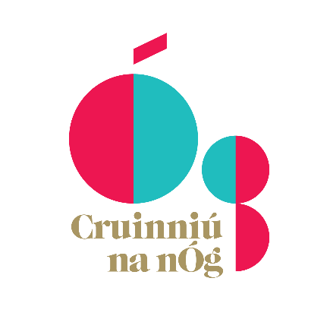
Creative Ireland: Cruinniú na nÓg 2023
Expression of interest
Closing date: Monday March 20th, 5pm.

Wexford County Council, in association with Creative Ireland, wishes to create a programme of events to celebrate Cruinniú na nÓg on Saturday June 10th, 2023. Cruinniú na nÓg is a National Day of Creativity for children and young people. It celebrates and encourages participation in culture and creativity through performance, workshops, readings, screenings, and special events. Events are free, local and activity based. It is a day for ‘doing,’ ‘making’ and ‘creating’!
We invite individuals and organisations to submit proposals for Cruinniú na nÓg 2023. We are looking for youth groups, arts organisations, artists, and all manner of experienced creative professionals. Using any medium or artform who have an interest and experience working with children and young people, to collaborate with us on this year’s Cruinniú na nÓg. (Theatre, dance, music, opera, film, circus, fashion, design, craft, photography, visual arts, digital arts, literature, storytelling, architecture, heritage, street art and spectacle). This open call is for activities, workshops, and showcase events for young people aged 0-18. Cruinniú na nÓg events can run in the lead up to Cruinniú with a main event on 10th June OR can be a one-off event happening on 10th June.
We are interested in receiving applications for innovative activities that foster creativity and engage diverse audiences, as well as applications that are designed in consultation with young people.

Selection Criteria
- The extent to which the proposed event/project maximises children, youth and community engagement and fosters creativity in young people.
- The extent to which the proposed event/project fits into the overall programme of events. The programme needs to reflect a diverse range of creative activities across the County.
- The potential scope of the event/project and anticipated target audience, including culturally diverse participants and audiences.
- The cost of the proposed event/project.
- Priority will be given to events that have been devised by or alongside young people.
- Your experience in delivering programmes for young people and in participatory/collaborative creative and cultural events

Conditions
- All projects must take place or have their final showcase on 10th June 2023.
- The event/workshop must be free for children to participate in.
- Funding may be used to cover all costs associated with running a workshop including materials - engage an artist - fund an exhibition - or performance of new work.
- Funding provided by Creative Ireland and Wexford County Council must be acknowledged in all publicity material associated with the work. The successful projects that receive funding will be promoted through the Wexford County Council and the National Cruinniú na nÓg website.
- Funding is available up to a maximum of €3,000 for a limited number of larger project-based events. However, there will be a number of one day workshops/activities funds set aside for smaller proposals
- It will not be possible to approve all proposals in which case funding will be allocated to those events which best meet the objectives of Cruinniú na nÓg and our programme criteria. The overall aim of the programme is to provide variety in terms of cultural & creative experience, age groups and locations, all of which will be considerations when deciding on applications.
- All applicants must be compliant with relevant legislation including Children First and any project involving young people must have the appropriate Child Protection Policies and/or certificates in place.
- All applications must submit a C.V. and at least one example of a previous work. For video and sound files, include links to online content only. Please remember to include passwords for password protected content.
- Only proposals with completed applications will be considered. Applications will be retained for one year and then will be destroyed in line with our data protection procedures.

Cruinniú na nÓg 2023
APPLICATION FORM
CONTACT INFORMATION
Name:
Organisation:
Email:
Contact Number:
EVENT PROPOSAL DETAILS
Title of event:
Type of event:
(Workshop, Performance, Exhibition, Reading etc.)
Genre:
Event description: (Please give the fullest description of the proposal.)
Please describe your proposal in no more than 3 lines.
Max 300 words. This is for promotional purposes.
Please give a brief description of your previous experiences of working with young people and/or designing events for young people.
Have young people been involved in putting forward this event? If yes, please give details (this is most applicable to youth organisations and venues)
Age of target audience /participants:
The size of the audience/participants your workshop or event?
EVENT BUDGET
Proposed expenses

Total Cost of Project | €
Amount Requested | €

CLOSING DATE FOR RECEIPT OF APPLICATIONS IS MONDAY 20TH OF MARCH 2023.
How to Apply
The application form and all supporting material must be completed and submitted by email to colette.ward@wexfordcoco.ie
For questions, please contact Colette Ward at colette.ward@wexfordcoco.ie
Successful candidates will be Garda Vetted and must have appropriate insurance and be compliant with relevant legislation including Children First.

Please attach the following documents along with your application. Please state here if you have supplied the following documents as attachments.
Child Protection policy
Relevant CV’s for projects proposal
Examples of your previous work - please include links only for videos
Are you willing to undergo Garda vetting by Wexford County Council

I consent to the processing and sharing of my personal data with the Wexford County Council and the Cruinniú na nÓg coordinator for the purposes of this award only. I believe that this information will not be used for any other purposes.

PRINT NAME:
DATE:

