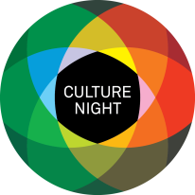
Culture Night 2018- Expression of Interest

This form is for artists, performers, and community groups that would like to participate in Culture Night on September 21st, 2018. If you require funding for your event you should complete Part C of the application form. Applying for funding does not guarantee that your event will be funded. You will be notified if you have been successful by mid July 2018.
PART A: Group/Organisation Information

Name of Group/Organisation:

Main Contact - name/phone/email:

Address:

Social Media/website:

PART B: Event Description (100 words max)

Pick a suitable category for your event (You can pick more than one):

Heritage ☐ Theatre ☐ Street Theatre & Circus ☐ Music ☐ Children & Family ☐ Irish Language ☐
Film ☐ Poetry & Writing ☐
Dance ☐ Art & Design ☐
PART C: Funding Requested

If modest funding becomes available to support your activity/event, how much would you request?

What would this support be used for?

Culture night takes place in various locations primarily in Wexford town but also in New Ross, Enniscorthy and Gorey towns. If you have a prefered location or venue requirements please make your preference known here:
(Times, venues, and location are at the discretion of the coordinator, but all efforts will be made to accommodate participants)

Please return completed expression of interest form to the Culture night co-ordinator: wexfordculturenight@gmail.com or post to Culture Night, The Arts Department, Wexford County Council, Carricklawn, Wexford

The closing date for receipt of submissions of interest is: Monday, June 25th 2018
Please also include a hi-res image for your event and your organisation logo for possible use in the brochure or website.

