**Wexford County Council**

**Per Cent for Art Commission**

**N25 New Ross By Pass**

Artist Caoimhe Kilfeather was awarded the Per Cent for Art Commission – N25 New Ross By Pass and is currently working on this commission due for completion and installation in early 2020

**Caoimhe Kilfeather**, studied at the National College of Art Design, Dublin and the Slade School of Fine Art, London. Her work is predominantly sculptural and often generated through experimental and intuitive processes in the studio alongside more targeted research and reading. The affect and experience of different materials, light conditions and scales is integral to the development of the work - both the context of *being in* architecture and the built environment as well as in landscape and the natural environment.

Recent solo exhibitions include *Elemental* at the West Cork Arts Centre (2019), *season and evening and weather and history* at the Douglas Hyde Gallery, Dublin (2017) and *this attentive place* at Temple Bar Gallery + Studios, Dublin (2014). Her work is included in many national collections such as IMMA, the OPW and the Arts Council.

She lectures in Sculpture and Combined Media at the Limerick School of Art and Design.

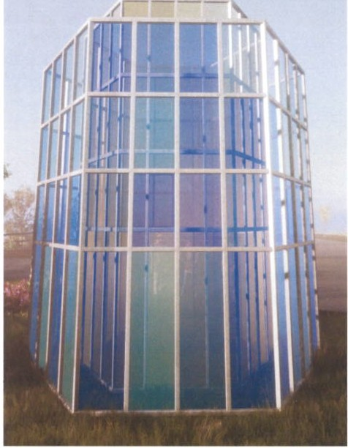**The N25 New Ross By Pass** commission will comprise of a glass and steel structures loosely referencing the local architectural landmark of the nearby Stokestown House Folly.

The coloured glass will reflect the landscape - the hues and tones of the fields, hedgerows and sky. On overcast days the glass will appear dense and opaque and on bright summers days more transparent - allowing views through to the surrounding landscape. In this way it is envisaged that the sculpture be dynamic and responsive to its site and to the elements.

At four and half metres in height the artwork will be a significant and striking element within the landscape.

The artwork will be situated at Stokestown overlooking new Rose Fitzgerald Kennedy Bridge.

(Proposed Artwork)



