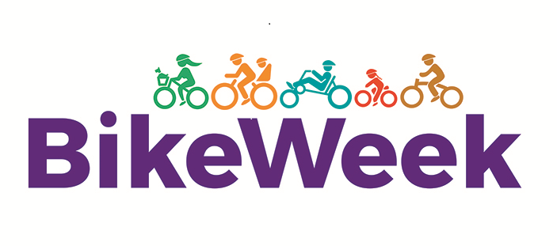
Bike Week Events 12th – 18th September

Date | Event Name/Details | Time | Who are the target participants for this event? | Location(s)
Bike Week | The South East Virtual Spin – Any Distance Any Day.  Register online: https://south-east-spin.webflow.io/  Free Snoods available for the first 250 registered | In your own time | Everyone | Virtual
Monday  13/9 | Norman Way Loop with talk from Catherine McLoughlin, Wexford County Council Heritage Officer  Organised by: Wexford Bicycle User Group  Register Online: www.axacommunitybikerides.com | 1.30pm | Adults | Carrick on Bannow – The Church car park opposite Colfer’s pub
Monday 13/9 | Bums On Bikes at Courtown BMX Club  To register email: courtownbmxclub@gmail.com | 5.30pm | Everyone | Courtown BMX Club, Riverchapel Community Complex
Wednesday 15/9 | Bums On Bikes at Courtown BMX Club  To register email: courtownbmxclub@gmail.com | 5.30pm | Everyone | Courtown BMX Club, Riverchapel Community Complex
Thursday  16/9 | Bike Maintenance Workshop with The Bike Shop Wexford  To register email: sportsactive@wexfordcoco.ie | 5-6pm | Everyone | The Bike Shop,  9 Selskar St, Wexford
Thursday  16/9 | Men’s Shed Cycle (Free Bike Hire available)  To Register email: sportsactive@wexfordcoco.ie | 10am | Men | Shielbaggan Outdoor Education and Training Centre, Ramsgrange
Thursday  16/9 | 5km Teen Cycle, Enniscorthy (Free Bike Hire available)  To register email: sportsactive@wexfordcoco.ie | 6-8pm | 13-18yr olds | Wexford County Council Machinery Yard, Enniscorthy, Old Dublin Road.
Friday  17/9 | Bums On Bikes at Courtown BMX Club  To register email: courtownbmxclub@gmail.com | 5.30pm | Everyone | Courtown BMX Club, Riverchapel Community Complex
Saturday  18/9 | Wexford Town Loop with Bike Safety Skills  Organised by: Wexford Bicycle User Group  Register Online: www.axacommunitybikerides.com | 9am | Adults | Wexford County Council, Carricklawn, Wexford
Saturday  18/9 | Mountain Bike taster for teens at Forth Mountain  Register through Shielbaggan Outdoor Education and Training Centre: 051 389550 | 9.30am | Teenagers | Forth Mountain
Saturday  18/9 | Balance Bike Come and Try Festival at Min Ryan Park  Bikes and Helmets provided | 1.30-3.30pm | 3-5yr olds | Min Ryan Park, Wexford

