Wexford County Council

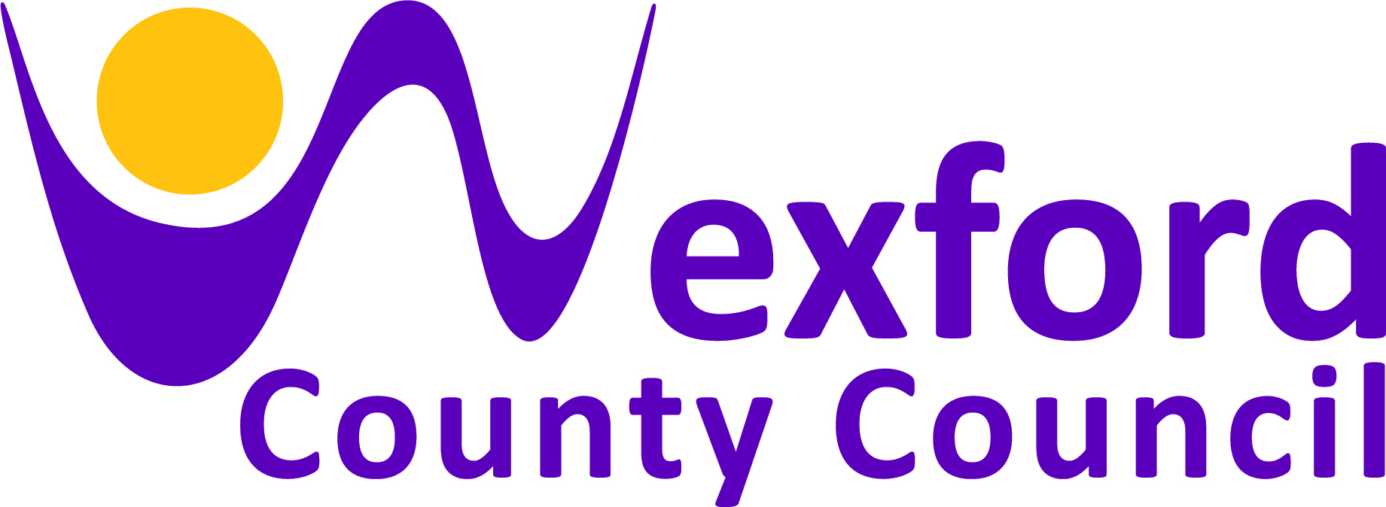

Professional Artist Panel
for the
Creative Communities Programme 2022

A panel of twenty-one professional artists,
proficient in enabling meaningful artistic collaboration.

Issued by: The Arts Department, Wexford County Council, Carricklawn, Wexford
January 2022

Name: Aileen Lambert
Art-form: Music – Traditional Song in Community Contexts
Contact: T: 087-7552593 E: aileenlambert@gmail.com

Projects/Workshops
Projects may involve researching and collecting local songs, learning songs and recording participants performance of songs, researching songs on a particular theme, working towards a themed performance. There have been songs written about almost any topic – sport, love, war, journeys, animals – is there is great potential to link a traditional song project with any group or individual’s particular interest. There is a great emphasis on enjoyment, building confidence, facilitating everyone’s participation and finding something that will interest everyone. Even is a person is not particularly interested in traditional singing as such, you can be sure to engage them in a lively action song, a comic song or a song about their favourite hobby, or hometown etc.

Visual Art Practice: Projects may also be supplemented with the use of photography and video and audio recordings of participant’s performances.

Parting note! I am thoroughly committed to the promotion of traditional song and continue to find ways to enable communities to connect with this part of our heritage. My wide range of skills and experience, (which includes performance art, video work, photography, undertaking public art commissions), and most of all my way of working with people places me in a perfect position to devise new projects with creative communities in county Wexford in 2022.

Background
I am a singer of traditional unaccompanied song, with a repertoire of songs particularly from the County Wexford English-language songs tradition. I have developed a unique practice in devising, co-ordinating and presenting traditional song projects in a diverse range of community contexts. These include after-schools workshops with children to national song research and composition projects with renowned traditional singers in association with the National Library of Ireland, with support from the Arts Council, along with my partner Michael Fortune. Such projects include ‘The 1916 Song Project’ (also supported by Wexford County Council) and the ‘Bird Song Project’ (supported by Age and Opportunity for Bealtaine 2015).

I am a specialist with the Heritage-in-Schools Scheme, delivering workshops in traditional song to Primary Schools, in Wexford and beyond, with songs suitable for children from infants up to sixth class. Communities I have worked with include communities of place, people with disabilities, special needs, older people, school projects with children of all ages and travelling community. In my projects I place value on the contribution of participants and support their own personal creative development within the overall arts project. Under the Creative Communities I have delivered numerous singing projects with diverse communities in recent years.

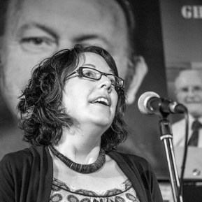 Aileen Lambert
Name: Andi McGarry
Art-form: Visual Art
Contact: E: sunmoonandstarspress@hotmail.com

Projects/Workshops
Specialising in

- Artist Led Collaborative Projects
- Boat Projects – 40 to date
- Artists' Books Projects – 11 to date
- Symposia
- Visual art workshops
- Exhibitions
- Gallery based activities
- Music Making Projects – 9 to date
- Collaborative film making projects
- Multi-disciplinary collaborative projects with a variety of communities

Background
I am an experienced artist and maker with an extensive background in participatory arts. I graduated with a MA in Social Practice and Creative Environment from Limerick School of Arts and Design. The nature of my visual arts practice has enabled me to interact and collaborate with many communities and education bodies managing the smallest of details of a project. I can start any project from the ground up. My varied experiences have enabled me to grasp how to form new collaborations and develop partnerships with a wide range of individuals, groups, agencies and funding bodies. I have a strong and distance leadership style and can galvanize groups and focus outcomes which follow good governance/best practice.

Much can also be achieved by fostering a spirit of encouragement, collaboration and mutual support often using humour as an effective tool. I’ve been actively involved and very successful in many different funding applications with many years planning and budgeting for variety of small. Medium and large-scale projects.

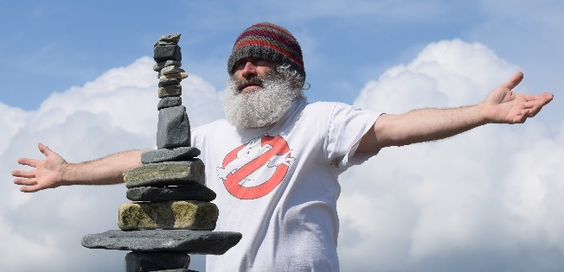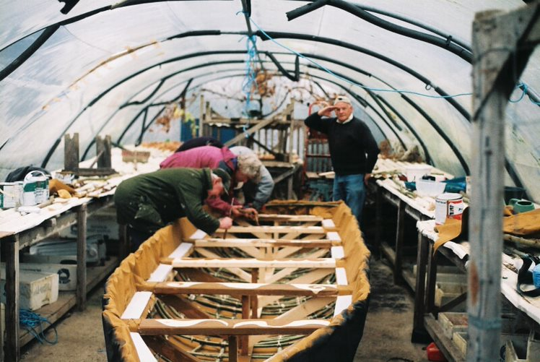
Artist – Andi McGarry Boat Building Project

Name: Caoimhe Dunn
Art-form: Visual Art – Puppetry, Carnival Arts, Street Theatre and Spectacle
Contact: T: 087 7549454 E: dunncaoimhe@gmail.com

Projects/Workshops
I can deliver workshops in a range of skills from large scale work like lantern processions and carnival arts parades, to more intimate indoor work creating shadow puppets, exploring light and dark. All workshops are individually tailored for the group participating and can include a mix of workshops building up to an indoor or outdoor performance, showcase or installation. Workshops can include the following:
Carnival Arts Workshops
Participants gain skills in large-scale prop and costume construction for outdoor performance, as well as the practicalities of working together in groups and performing as a team.

Mask Making Workshop
A great taster workshop for carnival arts – starting with a blank mask, using newspaper, glue and tissue everyone will create a unique piece with loads of character.

Shadow Play or Puppetry Workshops
Exploring light and shadow, texture and shape. Starting with found objects, creating images and characterisation, the workshop can develop into the creation of simple puppets to create more complex stories. Participants can also explore some different types of Puppetry - exploring movement/balance and weight, participants learn about the complexity of string puppets and how simple movements can be used to great effect.

Background
I am a Wexford based artist, an IADT graduate of both Fine Art and Model Making, and I’ve been involved for many years in Street Arts & Spectacle, Community and Youth Arts. Working with Greywood Arts for Halloween 2021, I created a lantern procession through Glenbower woods in Killeagh Co. Cork with the local community – celebrating Samhain, local history and coming together creatively again.

I’ve taken part in the Creative communities’ programme since 2017 including working with the GAP Arts Festival in 2020, collaborating with theatre-maker Garret Keogh to create an installation in the local woods and collaborating on a community-led film. In 2019 & 2020 I delivered the Street Spectacle Project for Kerry Arts Office, creating Spectacle performances with schools and community groups in Tralee, Killorglin & Killarney.

As part of my current practice, I’ve been researching and exploring folk traditions in Ireland. My work relies on the participation of communities to bring ideas to life. Passing on skills to others has always played a large part in my work.

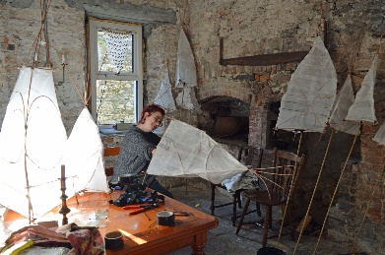
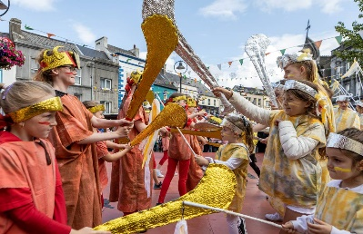

Queen Maeve’s Cattle Raid Parade at Enniscorthy Rockin’ Food Festival Caoimhe Dunn lantern making
Name: Cat Hogan
Art-form: Literature
Contact: T: 085-8757250 E: catherina.hogan78@gmail.com

Projects/Workshops
Workshops and courses can be organised specific to the requirements of each individual group and will focus on the power of words.

Background
I am an award nominated Irish Novelist and screenwriter from Co. Wexford. I’ve published two fiction novels, They All Fall Down (2016) and the Bord Gais Energy nominated Crime Fiction of the Year Novel, There Was A Crooked Man (2017).

I lecture in Creative Writing & Mental Health programs to young teenagers and adults, and tutors in Adult Literacy and Further Education. I’ve been a member of the Creative Communities Artist’s panel for a number of years. I’ve worked with multiple community groups in that time, including Acquired Brain Injury Ireland, Rehab Care, Youth Train and community groups, such as, Tomhaggard Women’s Shed, using Creative Writing Programs as a form of self-expression, enhancing creativity and recording stories through fiction and memoir, capturing stories from the community. I use creative writing as a tool to promote mental health and wellness.

I was the 2017 recipient of The John Hewitt Society Bursary Award and the University of Limerick Winter Writing School residency in 2018—returning to UL in 2019 as a mentor. I received the 2019 Bursary for Tyrone Guthrie. I was a Writer in (their) Residence for the Irish Writers Centre 2020. I was appointed Culture Ambassador for Wexford 2020. I was the recipient of The Literature Bursary Award with The Arts Council for her novel, ‘Let’s Play A Game’.
I am also a literary curator and regular panelist at literary festivals and events. As an avid promotor of culture and the Arts, I’m committed to equal access, inclusion and equality across all platforms.

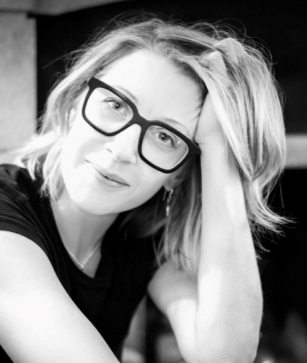 Cat Hogan

Name: Claudio Nego
Art-form: Visual Artist – Photography and Interdisciplinary Media
Contact: T: 089 4555468 E: claudio.nego@kamera8.com
Websites: www.kamera8.com ; www.claudionego.com

Projects/Workshops
I have worked with both artists and members of the public in creating knowledge and dialogue with the goal of growing and nurturing the public’s interest in photography and visual art in the context of the wider cultural life of Wexford and Ireland. Over the past two decades, having worked in mass media, I’ve developed extensive experience in the visual documenting of stories, events, places and people. I have also facilitated many projects with a wide variety of community groups. All projects/workshops are individually tailored for participants. Possible project/workshop ideas:
• Photography – From Basic to Art
A 6 week course with including photo trips and photo assignments, teaching photography from the very basic understanding of gear and software to discovering and applying exciting and more advanced knowledge to learners’ passion for photography.
• Mobile Phone Photography – Shooting, Photo Editing
This workshop that can be delivered either in one intensive session or several shorter ones is very suitable for groups, teaches basic photography theoretical elements (ex. composition colour, technique etc.) and also covers the basic photo editing skills using most popular Mobile Photo Editing Apps (ex. Snapseed).
• Complete Digital Photo Editing (Lightroom and Photoshop for Photographers)
The 6-week workshop covers all aspects of the Digital Editing Workflow (using Photoshop and Photoshop Lightroom), in a clear, hands-on, step-by-step programme, complete with exercises and assignments.
Background
A member of the VAI, I hold an Honours Degree in Photojournalism and Visual Communication and with over two decades of working in mass media I have extensive experience in visual documenting of stories, events, places and people. Starting my journey in the days of film shooting and darkroom processes and progressing with the transition into the digital technologies, I have worked on methods merging classic, analog techniques with the latest digital editing processes, with the purpose of preserving the essence and qualities of classic photography but ensuring its continuity into the “digital age”.

In 2016 I began the initial planning for photography co-operative and an exhibition and education centre for photography and related visual arts. In 2017, with the involvement and partnership of art curator Anya von Gosseln and photographer Michael Snoek, I co-founded KAMERA∞, in Wexford. During the 7 years living and working in Wexford, my photography concentrated almost exclusively on the life and heritage of Wexford and its surroundings, involving community groups.

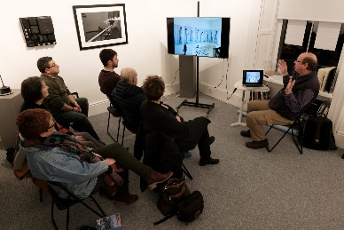

Photography Workshop
Name: Deirdre Travers and Sonya Weston
Art-form: Visual Artists
Contact: T: Sonya – 087-7874826 Deirdre – 083-3919544
E: Sonya - sonyaweston8@gmail.com Deirdre - deirdre.travers@gmail.com

Projects/Workshops
Both Sonya and Deirdre work collaboratively on projects and believe that creating art provides a sense of accomplishment and boosts self-esteem in all age groups. It also promotes wellbeing, creates a space for social connection, facilitates discussions and helps process emotions.
Deirdre - In our workshops we work with a variety of mediums and methods. It’s all experimentation, sometimes obscure. We encourage you to think outside the box but to also enjoy the process. All projects and workshops are structured to suit the ability and interests of all participants.

Past projects have included analogue photography and digital photography, image transfer techniques, stop motion film, set design, text-based work, collage, performance, public murals and printing techniques.

Background
Both Sonya and Deirdre have graduated from Wexford School of Art and Design with a B.A Hons in fine art in 2018/2019. Their art practice includes printing, sculpture, photography, film and performance. They have both participated as assistant artist on the Living Arts programme in primary schools and have worked collaboratively on several projects and workshops.

These projects were both from private and public organisations such as the collective Sensory Group, The Loretto Secondary school, Wexford Mental Health association, Windmill Therapeutic Unit and Wexford Arts Centre.

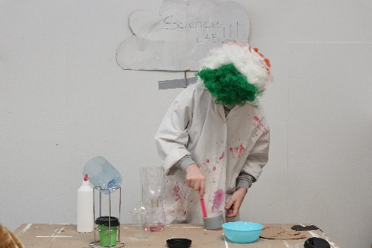

Sonya and Deirdre Loreto workshop Stop-motion film workshop

Name: Deirdre Buttimer
Art-form: Visual Artist
Contact: T: 086-8275494 E: deemeehanbuttimer@gmail.com
Facebook: https://www.facebook.com/Deirdre-Meehan-Buttimer-Visual-Artist-355328894828449/

Projects/Workshops
I specialise in Print / Mark Making with Inks and everyday objects. The type of Projects / Workshops I can provide are:

- Collaborating with community groups, to empower them voice their perspectives to a broad audience. Text / language forms a big part of my practice, across a range of media e.g., print / mark making, voice recording, journals, drawing, painting, photography, video. Public opinion / informed discourse can influence change.

- Outputs from sessions include collated/individual pieces, audio, journals, storyboards, video, installations, photographic material (physical and virtual format), usually exhibited.

Some examples of previous projects are below:
- Creative Communities project with Wexford Women’s Refuge. 6-month collaborative, developmental, text and object-based project, empowering participants to use personal experiences to describe Coercive Control. The facilitated text / experiences were expressed through a range of visual art media, triggering public debate/understanding.
- Adult’s print/mark making programmes, incorporating ‘stitching’, narrating everyday lives
- School residencies that:
  - engage a high % of students with a Traveller background, including cultural aspects that resonate with Traveller culture e.g., ‘beady pockets’, hair, sport, hunting, dogs, horses etc.
  - explored the impact and significance of farming and nature, incorporating local stories and histories
Background
I work from my sole and shared studio space(s) in Wexford, thriving on collaborative, hands-on engagement with participants of all ages and fellow artists. I facilitate “collaborative story telling using everyday objects”, the more personal the better, through community residencies, projects and workshops. These are experimental in nature, driven by my positive, intuitive and curious approach. My practice has a strong photographic/drawing element, using inks / mixed media. I use non-standard surfaces to print on and ‘stitch into’, e.g., paper tablecloths, plastic sheeting, and everyday objects, such as foliage, as ‘mark making’ tools.

I am strongly influenced by how we live our lives in interaction with our everyday surroundings/objects. My approach is to collaboratively gather found, gifted, source materials, take photographs, drawings, rubbings, and collect anecdotes and texts.

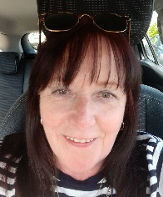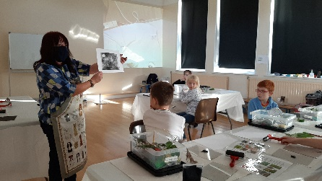
Deirdre Buttimer Printmaking Workshop
Name: Garrett Keogh
Art-form: Theatre and literature
Contact: E: gaarcy@gmail.com

Projects/Workshops
‘There’s no art in Ireland. No art, no minerals ...’
That was a teacher in primary school. Thankfully he was wrong, and I’ve enjoyed a career as an actor, writer, and director that has taken me around the world. Now, as part of the Creative Communities Programme, I’d like to share with you some of that experience. For pleasure, study, or performance, for pastime or profession, whether you want to write, act, direct, ot simply enhance your enjoyment of going to the theatre, I can offer an actor/writer/director’s insight into plays and playwriting.

In discussions with you, I will tailor a series of participative workshops suitable to your group of adults/young adults, concentrating on your choice of play/s, writers, genres, or on specfic aspects of theatre. These sessions will be in-person or online, and can be a hybrid of group and one-to-one workshops. In a hands-on system that I developed over many years, everyone in the group will voice the author’s words, and listen to others.

As in professional rehearsals, open discussion and interrogation of the text will examine the social, historical, cultural and stylistic contexts of the writing; and its relevance to our lives today. A practical hands-on approach is designed to break down the barriers between the reader and the text, to lift the words off the page, and to explore the wonderful illusion that audience, readers, performers and characters freely enter into.
Background
My journey as an actor has taken me from the Abbey Theatre Company to Broadway and the West End, from Connemara to Skibbereen, from an open-air performance in a coffin in Seán McDermott Street, to the dunes of Dollymount Strand, the rood of the Hellfire Club and the slopes of Annagh Hill. An award-winning writer, my work has been performed at the Dublin Fringe, Galway, Kilkenny, the New York First and the Gap Arts Festivals.
In a range of participative practices I have hosted workshops on Shakespeare for secondary schools, with adults returning to learning with the VEC, and with community and writers’ groups. In 2021 I devised the Gao Short-Short Showcase: new new theatre pieces, mostly from first-time writers, were presented at the Gap Festival. As part of Creative Communities Artist panel, I hosted a series of online playwriting workshops with Hollyforst Writers Group. These focused on women playwirghts, from the 1600s to the present-day.
In 2020, I hosted series of Arts Council workshops for adults online, exploring Synge’s In the Shadow of the Glen. https://www.youtube.com/watch?v=nuu0Kql2OXM Oibrím as Gaeilge freisin – bhain mé amach duais Script Teilifíse san Oireachtas.
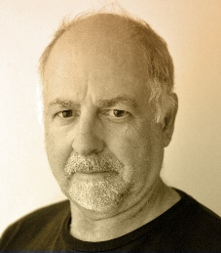 Garrett Keogh 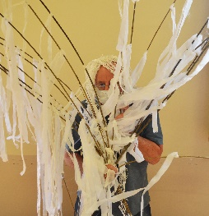 Community Project
Name: Jeni Roddy
Art-form: Interdisciplinary Artist
Contact: T: 089-2309753 E: jeniroddy@gmail.com

Projects/Workshops
I am a facilitator with experience working with a range of groups: children, teenagers and adults in contexts including galleries, classrooms and community settings and as an artist in residence. I have led and contributed to numerous public art projects and longer term programmes working in a wide variety of mediums.

I can provide workshops that include public participation from topics of sustainablity through to textiles. I like to create connections between people to help to ease social isolation. I often refer to my background in theatre and work with participants to create stories and build worlds.

The mediums that we use are dependent on the drive that the project takes as it develops, I follow the creative impluses of the participants to encourage ownership of the resultant work. The finished work could be an installation, a book or a performed event.

Background
I am an established visual artist and costume designer. I worked for 20 years producing live content through the mediums of theatre, film, live event and performance art. I work with textiles, nature and the body and look at how these intersect. I am interested in the question of value; how we value ourselves, each other and the material world that we are in. Through creating together I help to develop connections between participants and to evolve micro-communities.

I use whatever mode of creation suits the project as it develops; talking, story-making, drawing, stitching and playing. I am interested in giving participants tools to be confident in producing and speaking about art. I do this through visual thinking strategies encouraging the development of visual art literacy in participants.

My work is socially engaged and concerned with our connectedness to both the natural and socially constructed world. I am concerned with how we can live responsibility in our localities and globally, being mindful and creative in our daily lives.

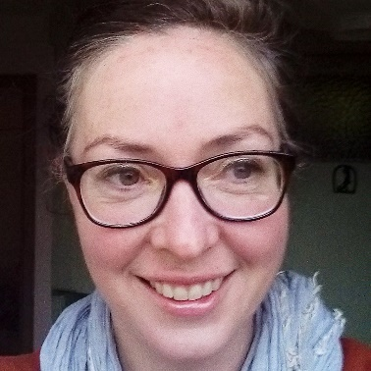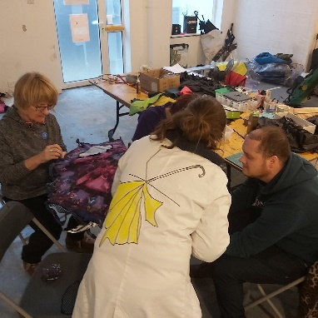
Artist Jeni Roddy Umbrella Orphanage Public Workshop
Name: Jimi Cullen
Art-form: Music - Musician, Singer-Songwriter, Guitarist
Contact: T: 085-7123525 E: jimicullenmusic@hotmail.com

Projects/Workshops
I am a Singer-Songwriter and Guitarist with 20 years’ experience in the music industry in Ireland and abroad. I have extensive knowledge of song writing, music exploration and performance practices as well as industry experience in recording and organising live events.
I specialise in facilitating Music Workshops and projects designed to engage young people, adults and groups through the medium of music. The aim of my workshops is to promote self-expression, personal growth, inclusion, creativity and participation within the community.

To date my Music Workshops have been delivered throughout Counties Wexford and Wicklow, I have had the pleasure of collaborating with communities from a wide range of backgrounds, these have included youth groups, mental health service providers, rehabilitation services, therapeutic training initiatives, primary and secondary schools and residential facilities to name but a few.

Music has the unique power to connect us through a shared experience, place or people, Workshops such as my own ask participants to collaborate on songs, discover new interests and express their unique point of view through music.

If you think your group/school might be interested in working with me, please give me a call or send me and email and we can discuss it in greater detail.

Background
I am a professional musician based in Gorey, Co. Wexford. I am currently working on my 7th studio album in a career that has seen me tour widely throughout Ireland and Europe sharing a stage with many acclaimed bands and artists. My love of music is what drives me to continue to write and record and is also why I work to promote music as a Community Music Tutor.
After many years working in a rewarding career within the youth, social, community sector I chose to pursue a new career where I could incorporate my love of both music and community activism.

A qualification in Youth and Community Work from U.C.C and training with the Train the Trainer program has provided me with the ability to design and deliver a bespoke programme of music workshops.

The music workshops I facilitate are designed to encourage a personal, social and creative learning experience through the many mediums of music. Previous participants have written songs, created bands/groups, recorded their music and put together performances both for the group and for their local communities.

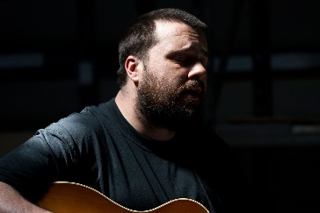 Jimi Cullen 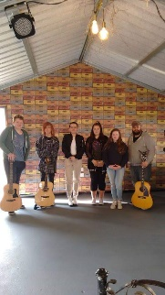 Music Workshop
Name: John Ó Faoláin
Art-form: Visual Art - Film, Photography, Digital
Contact: T: 087 7045961 E: traditionalarchivechannel@gmail.com

Projects/Workshops
I have extensive experience working with a wide range of groups and enjoy engaging in projects connecting people to their place. Most of my projects have been documented through photography & film and have resulted in performance or screening events. Over the years, I have been working creatively with community groups throughout Ireland to research and develop their understanding and connection with local history, folklore, customs and traditions pertaining to their place.
I also deliver digital skills programmes to various community groups and both primary and secondary school children throughout Ireland in conjunction with local authorities and county libraries. The groups and I work collaboratively to document and archive these projects through the groups newly developed photography & filming skills and the project outcomes are recirculated back into the communities in which they are delivered.
I would be interested in working with communities and groups on film & archive projects to create a documentary/film/publication on subjects such as local history, people, traditional music and song. I can also deliver educational programmes centered around filmmaking with both mobile devices or cameras which would include developing skills in directing, scripting, location, shooting, audio and editing etc. These workshops can be adapted to suit all ages and ability.
Background
I am a photographer, film maker, digital storyteller, culture & heritage researcher, educator and community artist with extensive experience in a diverse range of practices. Through my online archive Traditional Archive Channel, I work mainly in film and photography and my practice centres around collecting, archiving and sharing culture & heritage material, superstitions and folklore, material which is generated through conversations, relationships and interactions within a community or place.
To date, I have delivered socially engaged art projects through participation, collaboration, conversations and immersive experiences with a broad range of communities and groups/individuals from a wide range of backgrounds and ages. My most recent work was a touring and dissemination project where I filmed, edited and produced the Lorcán Mac Mathúna Quartet tour in Wexford, Dundalk and Mayo, connecting traditional and sean nós songs, music, folklore and poetry to the landscape.
With the support of Wexford local Development and Barnardo’s I have established the Wexford Youth Film Festival. The objective of this new festival is to encourage young people from all aspects of the community to get involved in filmmaking to help them develop their creativity in a community context. These projects have been funded by the Arts Council and local authorities.
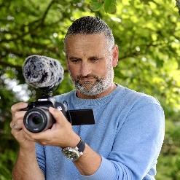 John Ó Faoláin 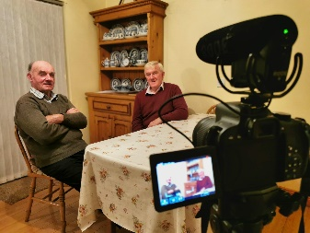 Folklore Workshop
Name: Kate Murphy
Art-form: Visual Art – painting, drawing, crafts, sculpture, mixed media
Contact: T: 086-3552203 E: katemurphyemail@gmail.com

Projects/Workshops
My approach to art-making centres on fun, humour, experimentation and 'thinking outside the box'. I like to try to new ways of working which may be outside the usual.
For newcomers to artmaking, my approach is to build confidence by making small steps, with an emphasis on finding the core of the group's interests, drawing out each participant's own visual language and art-making skills.

In the past, I have assisted groups with the following art practices: painting, drawing, sculpture, street-theatre head-dress design, mould-making, mural design, puppetry, paper crafts, mosaic, mixed media installation, construction, clay-modelling as well as in the areas of basic art theory, art appreciation and history.

An important part of making art is viewing the work of others and I would happily facilitate groups to visit exhibitions in Wexford or further afield.

Background
I graduated from the National Collage of Art 7 Design in 2000 with an honour’s degree in Fine Art. For the past 12 years I have worked in various collaborative/educational contexts with a wide range of participants, including Men’s Shed’s, Women’s groups, At-risk children, mental health groups, school groups and adults with disabilities. I worked for seven years on Wexford Arts Centre’s Insight Education Programme for children and have also delivered a number of adult projects with Wexford Arts Centre as well as with Wexford County Council Arts Office.

In 2017 I undertook a 10-week residency with Wexford General Hospital, working with patients and staff to create a permanent sculpture for the hospital. I recently completed an Azure training course on working through arts with people living with dementia.

I am currently working in Adamstown National School under the Living Arts Project, an artist-in-schools residency (Wexford Arts Centre and Wexford CoCo) and am looking forward to a number of forthcoming projects with Wexford Mental Health Services and with a number of Creative Schools projects.

I have worked as a professional visual artist since 2001, with a number of solo exhibitions in galleries in Dublin- and Wexford and have participated in group exhibitions nationally and internationally. My paintings have been purchased by the Office of Public Works, Bank of Ireland, Wexford County Council, Wicklow County Council and by private collectors.

I have also worked in the area of arts administration and am experienced in writing applications.

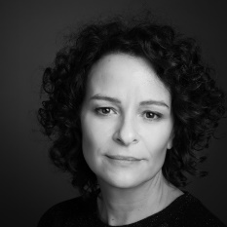 Kate Murphy 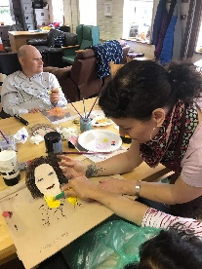 Children’s Workshop
Name: Melanie O’Reilly
Art-form: Music – Specialising in Singing
Contact: E: moreilly.newschool.ie@gmail.com
Website: www.melanieoreilly.com

Projects/Workshops
I specialise in singing and have facilitated many projects with a wide variety of community groups. All projects/workshops are individually tailored for participants. Possible project/workshop ideas:

- Community Singing workshops: Swinging songs repertoire for sing-along and to promote mental health & wellbeing and a sense of belonging. For adults and seniors for community centres or arts centres with outreach education.
- Community Choir Project: Directing community (small) group choir: teaching vocal singing with harmonies, a repertoire of easy to sing swinging songs for performance in the community.
- Outreach Concerts to community Senior Centres as well as nursing homes; Melanie & Trio singing and performing to entertain as a special event to those residents who are unable to get out to concerts in theatres or venues. We bring the music to them. Repertoire of easy listening swinging songs where residents would be invited to sing-a-along.

Background
I was born in Dublin and now I’m a resident in Wexford, I’m a singer, songwriter and music educator. I have recorded seven albums, performed on eight compilations, and I have performed at several international festivals, where I represented Ireland such as at the Los Angeles Schoenberg Hall, represented Wexford with my trio at the European Heritage Weekend in Normandy and was chosen to perform for Wexford’s Culture Night. I created and was host of the award-winning RTÉ radio show Jazz on the Bay.

I have extensive experience teaching singing and vocal performance as well as song writing in many schools and community centres. I am currently Jazz Artist in Residence at the Wexford Arts Centre, where I have created and developed a community outreach programme, bringing my Sing & Swing Trio into Senior Centres and Nursing Homes, and I have run a music education series entitled Singers of the Swing Era. I teach singing at the Wexford School of Music, and direct singing workshops for adults and children at Waltons School of Music and Carlow College of Music. I recently completed an MFA in Performance at the American College Dublin, where I also awarded Graduate Student of the Year.

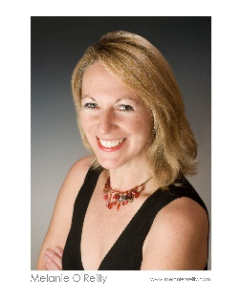Melanie O’Reilly 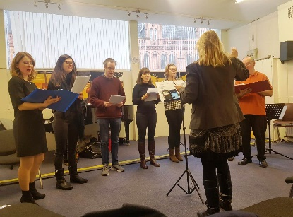 Vocal Workshop
Name: Michael Fortune
Art-form: Visual Art
Contact: T: 087 6470247 / 053 9256885 E: micfortune@gmail.com

Projects/Workshops
I am a socially engaged artist who collaborates and communicates with people in a variety of means using tools such as conversation, film, photography, social media, writing and mapping.
Some people know me as an artist and filmmaker, more as an educator, more as a collector of folklore and more as a lover of traditional song. I am a great communicator and thrive on bringing people on journeys via new ways of thinking and looking. I am also highly proficient in the use of digital technology and combines these skills to explore how we express ourselves and how communities connect and disconnect with the places in which we live.

There are many related strands to my practice. A project could take the form of a folklore collection. It could center around reviving an old custom in an area. It could take the form of a documentary about a local story or a body of songs about a place. It could bring hundreds of people together to walk through fields to look at what’s around them. It could manifest in a publication on vernacular furniture and design. It could come in the form of a digital map of the local area. It could be presented as an exhibition exploring objects and treasures hidden within our homes…. the list is endless.

However, what is really important is the genuine collaboration with people and my years of experience of working in this area.

Background
I have cut many furrows with my work for almost twenty years, and my practice has widened the conversations regarding the intersection of traditional and contemporary cultures in Ireland and the general appreciation and understanding of culture in all its manifestations, especially in the area of folklore, the ordinary and the everyday.

Working predominantly in film and photography, much of my practice revolves around the collection of material – material, which I have generated out of the relationships, and experiences I have developed with the people I encounter. I have produced an extensive portfolio of collaborative project work with people of all ages and abilities, both rural and urban throughout the county.
My works connect with many audiences and on many levels, and I am as comfortable presenting work in a village hall in Wexford as I am at an international film festival or gallery in Mexico. In recent years much of my work is presented on social media platforms while I also contribute articles and features for various local, national and international papers as well as RTÉ Radio and television. I run a page called folklore.ie on Facebook which acts as an open studio to my practice and it currently reaches between 500,000 – 2.4million people every 4 weeks.
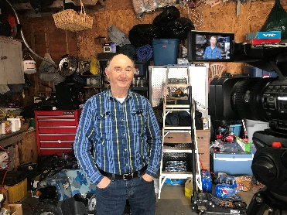Socially engaged project
Name: Michelle Dooley Mahon
Art-form: Author, Playwright, Performer, Broadcaster, Artist, Photographer, Carer
Contact: E: michelledooleymahon@gmail.com
Website: www.shellshock.ie

Projects/Workshops
As a multi-disciplinary practitioner, I have vast experience in many areas including creative writing, press releases, non-fiction, social media, journalism, editorial, podcasting, radio presenting, multi-media, stage craft, production and tech, and caring for the elderly.
I could provide workshops for community groups in any of the above areas and also in the art of wellness including meditation, holistic therapy, guided trance, the art of allowing, natural healing, and the purpose of being alive in this lifetime.

I also do motivational talks and am a mental health advocate as well as an ambassador for the Alzheimer’s Society of Ireland and have contributed a Ted Talk for them.

Background
I have worked for 30 years in the hospitality industry and have been employed front of house in Ireland, England, Wales, Germany and Spain. I have managed hotels, restaurants, and licensed premises all over Europe.

When my mother was diagnosed with Alzheimer’s I gave up my job as a Hotel Manager in Rosslare and became her carer for 7 years.

I started writing and performing One Woman Shows during her illness. I wrote a book about it called Scourged the play adapted from the book “The Scourge” toured Ireland and to New York, winning an award for the writing.

During lockdown I performed 2 new shows, created and presented the #mdmpodcast and am writing a sequel to Scourged called “Spiders don’t eat biscuits”

At present I am the carer of my 91-year-old Father Tom.

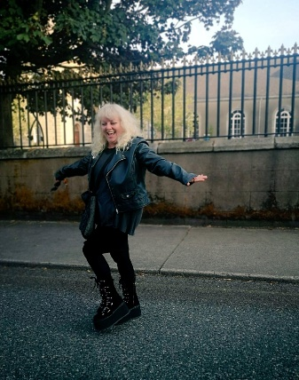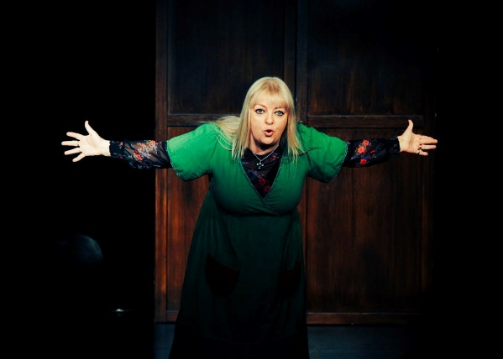
Michelle Mahon Dooley Stage Production

Name: Rachel Rothwell
Art-form: Visual Arts – Specialising in painting, illustration, ceramics, bookmaking, creative workshops
Contact: T: 087-2976723 E: rothwell.rachel90@gmail.com
Website: www.rachelrothwell.net

Projects/Workshops
I work in a variety of media, ranging from painting and illustration to ceramics and installation. I am passionate about the benefits of art as a tool for learning and building community and seek to promote these principles in my practice. Workshops are a collaborative process and can be tailored to the participating group’s interests/needs.

I can provide workshops involving painting, illustration, ceramics, bookmaking with a focus on socially engaged practice. I have comprehensive experience working with children and young people, both in school settings and community spaces and also work regularly with adults. I enjoy facilitating projects that encourage inter-generational collaboration.

Background
I graduated from Limerick School of Art and Design in 2012 with a BA in Ceramics. From 2015-2017 I lived in Switzerland, where I was a secretary and resident artist at the arts association Loft A46 before completing my MFA degree in Socially Engaged Art at the Haute École d’Art et de Design in Geneva in 2019.
I have a strong track record in working in educational settings, both as an educator and as an artist. I am currently a Lead Artist in the Living Arts Project and have worked with students in Ireland and internationally to bring creative projects to fruition.
I 2020 I received an artist bursary from Creative Ireland and Wexford County Council, with which I set up the community project Wexford Stories, collecting stories about people and places that make Wexford special. I also ran public workshops online and in person, examining our relationship to memory and place.

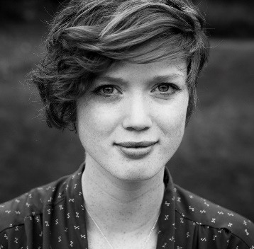 Rachel Rothwell 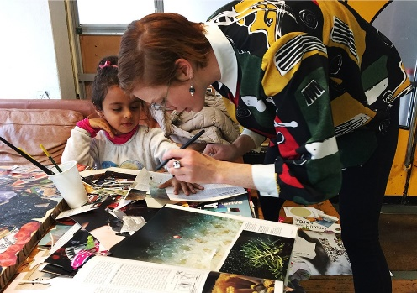 VA Workshop

Name: Rachel Uí Fhaoláin
Art-form: Music - Traditional Song and Visual Art
Contact: T: 087 2988473 E: ceolmochroi@gmail.com

Projects/Workshops
I specialise in delivering traditional song programmes/workshops and have extensive experience in research, composition & collection projects. People, place, language and folklore are at the core of my work. My practice aims to develop and enhance intergenerational conversations through singing, music, storytelling, poetry and the Irish language. I am increasingly exploring multicultural traditions and language so as to better understand and connect our cultural similarities in a meaningful way. Traditions and heritage are universal. It is a connection that we all share. Language and social barriers can be dismantled through effective engagement in the traditional arts.
I work with communities to document and archive these projects through photography, film, publications, radio production etc. and the projects have resulted in performance, screening and launch events where the material is recirculated back into the communities in which it is collected. All of my composition and collecting work with the older generation feeds directly into my work with the younger generation, an important aspect of the transmission of our song tradition, folklore, language and stories.
Let’s start a conversation about your group’s interests and we can develop the project from there. I’ll bring the biscuits! Míle buíochas, Rachel

Background
I have been at the forefront of the traditional song heritage in County Wexford for over ten years. I deliver intergenerational traditional/sean nós song, music, culture & heritage programmes to a wide audience through Ceol Mo Chroí and I am a founding member of the North Wexford Traditional Singing Circle. I have extensive experience of delivering traditional song programmes to primary school children in Wexford and throughout Ireland as part of the Heritage in Schools Scheme and my Library Residency work. My most recent publications include a new DVD collection - The Nursing Home Project, which contains valuable accounts of life, stories and folklore connected to place, and also a new song book with accompanying DVD that presents a collection of newly composed songs in the traditional style for both adults and children.
I enjoy meeting and working with new groups across all ages in County Wexford and throughout Ireland. We all have a story to tell. I have transferred my extensive Pharmacy and Biobanking skills of dispensing, researching and storing critical medical samples to the important preservation and archiving of our rich oral traditions. ‘Critical material’ being stored carefully by initiating conversations and presenting them in a tangible way to help understand and describe the world around us.
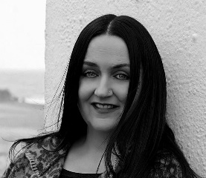 Rachel Uí Fhaoláin 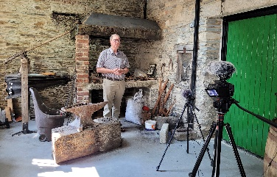 Traditional song book Project
Name: Sharon Clancy
Art-form: Live & Audio-Visual Performance/Development, Production, Acting & Singing
Contact: T: 085-8238665 E: sharonclancy77@gmail.com

Projects/Workshops
I am delighted to offer a wide range of tailor-made workshops to a broad spectrum of groups and individuals. Having an extensive background in performance and creative development in live theatre and audio-visual projects, I can devise something unique and exciting for each project.
Fun Musical Theatre/Acting Workshops/Courses- A great fun taster into the world of Singing, Dancing and Acting. This can be a day workshop, or a large-scale production/course run over a number of days/weeks. This is a wonderful way to bring people of all ages together. Time can be spent with your group teaching them the principles of acting and performing through drama games and improvisations and practical practice. Creating original works by devising a creative piece based around a specific subject or important social issue is an ideal way to facilitate and give voice to those who sometimes may not have a platform to express themselves. Mindfulness, self-awareness and confidence building work beautifully in tandem with all my projects and courses.

Creating Audio Visual Workshops/Courses – Have you ever wanted to make your own Movie? This course can be tailor made to suit numbers, different age groups and time restrains. With a world that is now almost totally viral and virtual an Audio-Visual Project is an ideal way to get a message or story out to a much wider audience even worldwide via the web.
On this course myself and my camera crew will guide you through the art of film making. From the Idea Phase to actualising a completed Audio-Visual project. Directing, Scripting, Casting, Locations Scouting, Shooting, Editing, Promoting and Publicising. If there is a message or story within your group or community that is waiting to be shared this could be the ideal project for you.
Background
With over 20 years’ experience in London performing in numerous Westend Musicals like Mamma Mia, Jesus Christ Superstar, Grease and The Rod Stewart Musical and Presenting on Sky TV, Channel 5 and RTE, traveling the world on the Queen Mary 2 as lead vocalist and Disney Cruise line, I am truly grateful to have earned my strips in the world of entertainment.

Since returning to Wexford in 2012 I set up Superstars Stage Academy in Wexford, Enniscorthy and Kilrane/Rosslare HBR where children from the ages 4 to 16 years sing, dance, act and build their confidence with me and the Superstars team every week, I write, direct, costume and produce two large scale productions every year where 100’s of kids get to perform on the National Opera House stage in Wexford town. I run Superstars Glee Club Wexford and I am part of the vocal harmony group The Ivy Sisters. I have produced and directed documentaries/films for Rehab Care, County Wexford Youth Project and Youth Train to name a few.
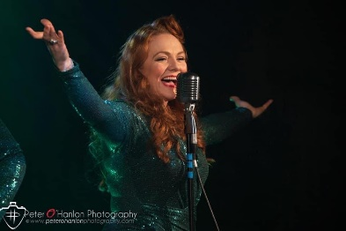 Sharon Clancy 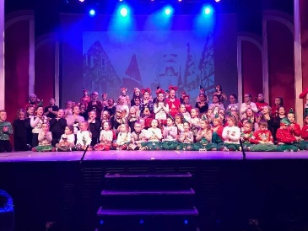 Superstars Camp
Name: Sylvia Cullen
Art-form: Literature
Contact: E: cullensylvia@outlook.com

Projects/Workshops
Facilitation of short-term creative writing courses for children, teenagers or adults. Typically, these workshops focus on a variety of exercises and approaches to writing, in a positive and encouraging atmosphere.

Each individual will be supported to pursue their own writing goals, with a view to producing new work. Complementing this, is time spent learning how to edit each piece – identifying structural problems and inconsistencies. Participants will learn the skills required in order to serve the story.

Often, a course is rounded off with a reading and/or the launch of a collection of new writing. Examples of recent work include Surviving the Darkness with Wexford Women’s Refuge, Dancing Down Memory Lane with Riverchapel/Courtown Ladies Club, Moving Words with Crushin Traveller Women’s Group and How to Skin a Rabbit for the Gap Arts Festival.

Background

I am a published playwright and short story writer, who was educated at Trinity College Dublin and the University of Sydney. I live in rural North Wexford. Where Three Waters Meet, my collection of four Wexford-inspired stories for Creative Ireland, is available as a podcast online. The Book of Tomnafinnoge, funded by an Arts Council Literature Project Award, is a new collection of short stories which I edited, including work by children, teenagers and adults.

Over many years, I’ve worked with a variety of community groups in Wexford, Wicklow, Tipperary, Carlow, Waterford and Dublin. From 2006 – 2019 I was writer-facilitator for the award-winning Arts Ability Creative Writing Progamme at K.T.A.C. in Enniscorthy. In addition to being a member of the Arts Council’s Writers-in-Prisons panel, I have also worked with Women’s Travellers’, Youth and Active Retirement groups. My most recent Creative Communities literature project is Gorey Stories with Gorey Youth Needs.

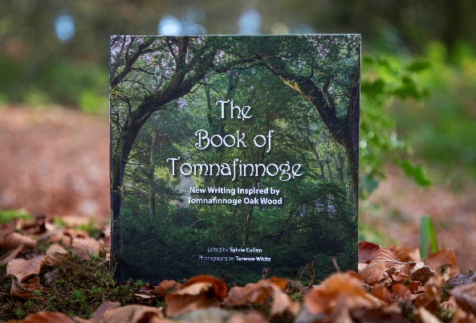

The Book of Tomnafinnoge

Name: Vivian Brodie Hayes
Art-form: Dance and Film
Contact: T: 087 7622312 E: info@vivianbrodiehayes.com
Website: www.vivianbrodiehayes.com

Projects/Workshops
I enjoy collaborating with other artists, people and groups and am happy to talk over ideas for projects, no matter how small, specific, unusual, or different. I enjoy working with people new to dance/creative movement and people who have experience. I can develop plans based on creative dance projects from my previous work or develop an original idea with a group or co-facilitator. I have a lot of experience in setting up new creative dance or movement projects and have had many successful creative communities’ projects. I enjoy the creative process and understand how each group has different needs, expectations, and interests. I appreciate the time it can take to get to know the group and tailor the content of the project to the group’s specific interests.
Creative Dance Projects
I can facilitate creative movement projects that will have movement sessions/dance sessions around a theme or idea proposed by the organisers or group.

These projects can culminate in a short film, a sharing, performance or gathering, the making of printed materials/booklet or as an audio sound recording.

I can work with small groups or large groups and can collaborate with other artists on co-facilitating a project.

Background
I am a choreographer, dancer and an active community artist with a MA in Contemporary dance. I was born in California, worked for over a decade in New York and now live in county Wexford. I have been working as a dancer, facilitating creative dance projects for over 20 years.

I have a huge belief in the joy of movement and love to bring creative dance into people’s lives. I work across the lifespan, with children, teens, adults and am happy to work with any individual of group who has specific needs.

I am currently the Dancer in Residence in partnership with the National Opera House and Wexford County Council Arts Department, funded by the Arts Council. I am the founder and director of SpringMoves Dance Festival and Dance Hub Wexford and am the Yoga and Movement Specialist (YAMS) with Wexford Mental Health Association. Some of my recent projects include, Dolmen (research searching 2021), The Three Pillars (collaborative arts project 2021), Swifts and Swallows (film 2021), I Take This Place (film 2020), 9 Flock Dancers (performance 2019), Siblings (film 2017) Incidental Music (performance 2016), bboy (film 2016).

Vivian Brodie Hayes Creative Dance Project
