COMMUNITY ENHANCEMENT PROGRAMME 2019 – Measure 1

NOTE: Closing Date 30th May 2019

FOR OFFICE USE ONLY

Date Received:

Reference Number:

LCDC recommendation:

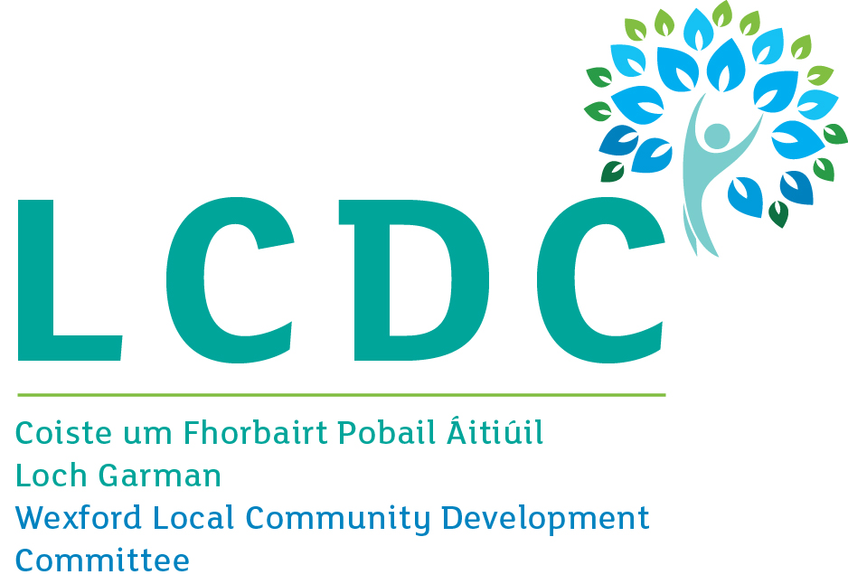

GROUP /ORGANISATION NAME:

ALL APPLICATIONS ARE TO BE RETURNED TO:
Wexford LCDC,
C/o Community Development Section,
Wexford County Council,
Carricklawn,
Wexford Town,
Y35 WY93

By 5pm on Thursday, 30th May 2019
CLOSING DATE WILL BE STRICTLY ADHERED TO.

Please read the CEP Application Guidelines before completing this form.

Department of Rural and Community Development
Community Enhancement Programme

The Department of Rural and Community Development (“the Department”) operates a grant programme through the Local Community Development Committees (LCDCs). This capital grant programme provides funding to enhance facilities in disadvantaged communities. Applications should relate to one or more key priority areas identified in the LCDC Local Economic and Community Plan (LECP) in order to be eligible for consideration.

TERMS AND CONDITIONS

- Under the Community Enhancement Programme (CEP), which is funded by the Department, grants will be provided towards capital projects to enhance facilities in local communities. The scheme does not provide funding for the employment of staff.
- The maximum grant available per project unde measure 1 is €1,000. This limit may be exceeded in limited and confined circumstances. Match funding is not required.
- The activity or project must benefit the local community and relate to the key priority areas identified in the LECP.
- The information supplied by the applicant group /organisation must be accurate and complete.
- Misinformation may lead to disqualification and/or the repayment of any grant made.
- All information provided in respect of the application for a grant will be held electronically. The Department reserves the right to publish a list of all grants awarded on its website.
- The Freedom of Information Act applies to all records held by the Department and Local Authorities.
- The application must be signed by the Chairperson, Secretary or Treasurer of the organisation making the submission.
- It is the responsibility of each organisation to ensure that it has proper procedures and policies in place including appropriate insurance where relevant.
- Applications must be on the 2019 form.
- Evidence of expenditure, receipts /invoices must be retained and provided to the LCDC or their representative if requested.
- Grant monies must be expended and drawn down from the LCDC by end of year 2019. Photographic evidence may be required to facilitate draw down of grants.
- The Department’s contribution must be publicly acknowledged in all materials associated with the purpose of the grant.
- Generally no third party or intermediary applications will be considered.
- Late applications will not be considered.
- Applications by post should use the correct value of postage stamps and allow sufficient time to ensure delivery not later than the closing date of Thursday 30th May, 2019 at 5pm. Claims that any application form has been lost or delayed in the post will not be considered, unless applicants have a Post Office Certificate of Posting in support of such claims.
- Breaches of the terms and conditions of the grants scheme may result in sanctions including disbarment from future grant applications.
- Please ensure the application form is completed in full. Incomplete applications will not be considered for funding.
- In order to process your application it may be necessary for Wexford County Council to collect personal data from you. Such information will be processed in line with the Local Authority’s privacy statement which is available to view on www.wexfordcoco.ie.

All questions on this form must be answered. Please write your answers clearly in block letters.

SECTION 1 – YOUR ORGANISATION

Name of Group / Organisation

Address

Eircode

Contact name

Role in Group/Organisation

Telephone number

E-mail

Website

Alternative Contact name

Alternative Telephone number

Alternative E-mail

Please provide a brief organisational description of your group / organisation e.g. committee structure, meeting schedule etc. _________________________________________________

___________________________________________________________________________

Has your Organisation / Group registered with the relevant local Public Participation Network (PPN)?
YES ☐ NO ☐

If NO, then perhaps you would consider joining the PPN.

Year established ________

What is the purpose of group / organisation _________________________________________
____________________________________________________________________________

Successful applications for funding under this programme will only be paid to the applicant organisation’s Bank Account. Please ensure you have your Bank Account details to hand if your application is successful.

Have you received funding under any capital grants schemes from 2016 to current date- i.e. grants from Government Departments, Local Authority or LEADER?

YES ☐ NO ☐

If YES please give details below:
Name of scheme | Funding organisation | Amount of funding

If any of the above funding was paid through the Local Authority, have you submitted your Bank Account Details previously?

YES ☐ NO ☐

Do you receive funding from any other organisation?

YES ☐ NO ☐

If YES please give details below:
Funding organisation | Amount received | Date received

Is your organisation affiliated or connected to any relevant local regional or national body?

YES ☐ NO ☐

If YES please give details below:
Name of organisation(s): _______________________________________________________

___________________________________________________________________________

How does your organisation link in with other organisations in your area? _________________

____________________________________________________________________________

Charitable Status Number (if applicable): ___________________________________________

Tax Reference Number (if applicable): _____________________________________________

Tax Clearance Access Number (if applicable): _______________________________________

SECTION 2 – Project Details

PURPOSE OF GRANT

What will the funding be used for?
Note: This list is not exhaustive, but gives examples of types of capital expenditure

☐ IT Equipment ☐ Sports Equipment ☐ CCTV
☐ Signage ☐ Training
☐ Upgrade of building ☐ Upgrade playground ☐ Safety Equipment
☐ Defibrillator ☐ Energy efficient upgrade ☐ Research facilities
☐ Development of community facility ☐ Other (Give details)

______________________________________________________________________________

What is the purpose of the grant? (Outline details of the project).

When will your project begin? ________________
When will your project be completed? ________________

Are all relevant permissions in place (e.g. planning, written consent from landowner/property owner if your project involves the development of a property)?

Not applicable ☐ YES ☐ NO ☐

Is this part of a phased development and/or linked with (or funded by) other schemes operated by Government Departments or the Local Authority?

YES ☐ NO ☐

If YES please provide the details below:

FUNDING

Amount being applied for under the CEP: | €
Is this amount partial or total project cost: | ☐Partial | ☐Total
If partial, give estimated total project cost: | €
Important note: Please include supporting documentation.

- If your project is for Building/Landscaping/Construction and the total cost is less than €5,000.00 , please include quotes from a minimum of three different independent suppliers.

- If your project is for Building/Landscaping/Construction and the total cost is greater than €5,000.00 and less than €50,000.00, please include quotes from a minimum of five different independent suppliers with this form.

- If your project is goods/services and the total cost is less than €25,000.00, please include quotes from a minimum of three different independent suppliers with this form.

To be eligible for funding under this programme you must state where you will source any shortfall of funding. Please provide these details below.

Source | Amount

Has your organisation availed of funding under the Communities Facilities Scheme or RAPID in 2017, or the 2018 CEP, or the 2018 Mens’ Shed fund?
YES ☐ NO ☐

If YES, please give details of the project which received funding in 2017 and/or 2018:

____________________________________________________________________________

_________________________________________________________________

Please state how your group proposes to publicly acknowledge the Department, LA or LCDC

______________________________________________________________________________

The LCDC will check to ensure that this application works towards addressing priorities within its Local Economic and Community Plan (LECP) which you can access from the LCDC section of the Wexford County Council website www.wexford.ie (under the Community Section). If your application is for an amount greater than €1,000, please complete the below table to state which key priority area(s) in the LECP this grant application relates to and the estimated number of people to benefit.

If your application is for a small scale capital grant of €1,000 or less, then you may wish to complete the below table, but you are not required to do so.

Key priority area of LECP | No. of beneficiaries

SECTION 3 - DECLARATION

- I declare that the information given in this form is correct.

- I confirm I have read and fully understand the Terms and Conditions of the Community Enhancement Programme (see page 2 of this form).

- I confirm that I have read the Community Enhancement Programme Application Guidelines prior to completing this form.

- I confirm that this grant application is submitted in acceptance of and compliance with the Terms and Conditions.

- I confirm that the applicant group/organisation does not have the funding to undertake the work/project without this grant aid or alternatively that with the grant will facilitate a larger project which they otherwise would not be able to afford.
- I confirm that the applicant group/organisation is tax compliant (if tax registered).

Name in block capitals (on behalf of group / organisation):

Signature:

Position held in group / organisation (block capitals):
Date:

Data Protection Acts, 2018 & GDPR Regulations
Paper and Computerised Records
Wexford County Council is responsible for delivering the Communities Enhancement Programme 2018 in County Wexford and is required to collect information from individuals and community groups who it assists with grant aid under this Scheme.

Some of the information sought is personal data and sensitive personal data which will be processed and securely stored by Wexford County Council in paper and electronic form in compliance with the above Acts and GDPR Legislation.

Information subsequently received may be added to such records. You, as a Data Subject, have a number of rights under the Acts, including access to your information.

Requests should be addressed to: Freedom of Information Office, Wexford County Council, County Hall, Carricklawn, Wexford Town, Y35 WY93.

The information we record will be used only for the following purposes:
- Processing applications
- Compiling statistical information
- Analysing information about applicants for other bodies such as Government Departments e.g. The Department of Rural and Community Development.
- Publication of applicant and project details (including photography) for publicity and promotional purposes.

Personal data will be disclosed only in accordance with Wexford County Council’s duties under the Data Protection Acts. For further information on our privacy policy see our website.

DECLARATION
I have read and understand the above statement and give consent to Wexford County Council for the use and disclosure of data and information as outlined above.

Name:

Date:

Wexford County Council requires the procurement of goods and services, in a manner, to ensure at all stages of the development and / or retrofit of publically funded facilities that accessibility and equality (access and equality for end user) is accounted for, In line with Disability and Equality Legislation.

