Gorey Municipal District Ferns (National Roads) Village Renewal Project
Streetscape Paint Scheme 2018

APPLICATION FORM

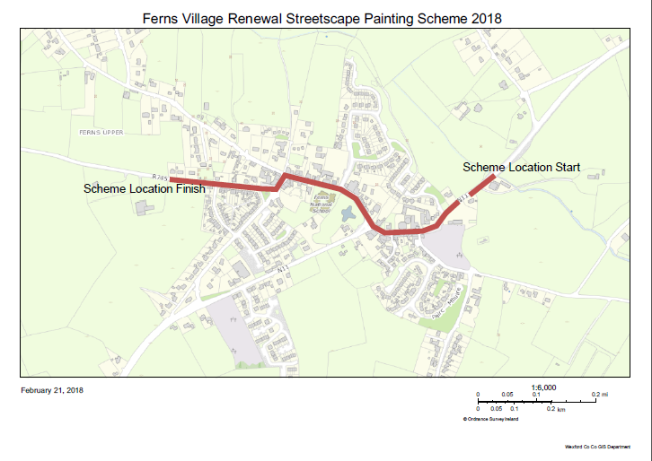

MAP OF FERNS

Completed Application Forms to be returned to:
Gorey Civic offices
Wexford County Council
The Avenue
Gorey
Co. Wexford

Gorey Municipal District Ferns (National Roads) Village Renewal Project
Streetscape Paint Scheme 2018

Terms and Conditions

- A Fund has been made available by Wexford County Council for the Gorey Municipal District Ferns Streetscape Paint Scheme 2018.

- The scheme will offer a grant of €500 or 50% of the cost of the work - whichever is the lesser - to each applicant who is successful in the application process.

- The Gorey Municipal District Ferns Streetscape Paint Scheme 2018 is funded by the Village Renewal Programme and Wexford County Council. It is confined to commercial and residential premises on the parts of the National N11 and Regional road R745 within Ferns village, as indicated on map above.

- Applications are invited from owners and/or occupiers of both Commercial and Residential Properties (with the consent of the owner/s).

- Local Authority Charges due by Applicants must be paid up to date e.g. Commercial Rates, Local Property Tax etc.

- Applications are open from March 1st to March 31st – subject to funding being available.

- If the scheme is oversubscribed those applicants eligible to continue in the application process will be randomly selected.

- Those applicants eligible to continue in the application process will be notified by email unless otherwise requested.

- Those applicants eligible to continue in the application process will be invited to submit their selected quotation, detailing the proposed work including the proposed colour scheme.

- An approved colour palette, which may be used on rendered surfaces, will be issued with the application form.

- Alternative colours may be used on rendered surfaces, subject to the approval of Wexford County Council. Proposed Colour Schemes must be submitted with the quotation.

- The colour of timber elements including shopfronts will be subject to the approval of Wexford County Council. Proposed Colour Schemes must be submitted with the quotation.

- Some areas of Ferns are located within Architectural Conservation Areas and some properties are Protected Structures. Wexford County Council will address any conservation issues relating to the proposed work prior to issuing grant approval.

- Grant Approval will be issued in writing to successful applicants.

- Successful applicants will be required to obtain all necessary consents and comply with legislation and codes of practice which apply to such work.

- The successful applicants will be required to complete the approved works, in a satisfactory manner, and within a specified time frame.

- The successful applicants must apply for payment of the approved grant (by submitting invoice) when work has been completed and in any event before June 30th, 2018.

- Payment of the grant will be subject to completion of the approved work in accordance with the conditions outlined above.
Comhairle Chontae LOCH GORMAN
WEXFORD COUNTY COUNCIL

Gorey Municipal District Ferns
Streetscape Paint Scheme 2018

Applicant __________________________________________________

Postal Address __________________________________________________

__________________________________________________

Phone Number __________________________________________________

Email Address __________________________________________________

Business Name of
Nominated Property _________________________________________________

Address of
Nominated Property _________________________________________________

Please Give a Description of the Nominated Property Overleaf

Are you the owner of the property? YES NO

If the applicant is not the owner, the written consent of the owner must be included with this application form. Alternatively the owner may give consent by signing this form in the space indicated below.

Total Cost of Proposed Works

APPLICANT _________________________ DATE _______________________

I, __________________________________
(Please Print Name)
hereby give my consent to have the front façade of the nominated property referred to above, painted in accordance with the terms and conditions of the Gorey Municipal District Ferns Streetscape Paint Scheme 2018.

_____________________________________ DATE ______________________
Signature of Owner of Nominated Property

Description of Nominated Property

Please include the following information together with any other information you consider relevant: -

- Does the nominated façade constitute part or all of the front façade of the building?
- If all of the facade, please state the number of floor(s) to be painted.
- If part of the facade, please state the number of floor(s) to be painted and the number of other floors.
- What is the current designated use or traditional use of the nominated property?
- Is the nominated property currently occupied / vacant / part occupied?

- ______________________________________________________________________

- ______________________________________________________________________

- ______________________________________________________________________

- ______________________________________________________________________

- ______________________________________________________________________

Additional Info:

______________________________________________________________________

______________________________________________________________________

______________________________________________________________________

______________________________________________________________________

______________________________________________________________________

______________________________________________________________________

______________________________________________________________________

______________________________________________________________________

______________________________________________________________________

______________________________________________________________________

______________________________________________________________________

______________________________________________________________________

______________________________________________________________________

