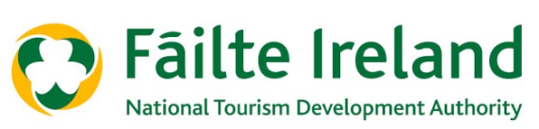
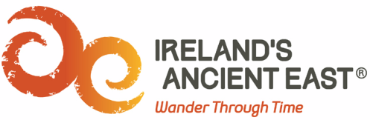
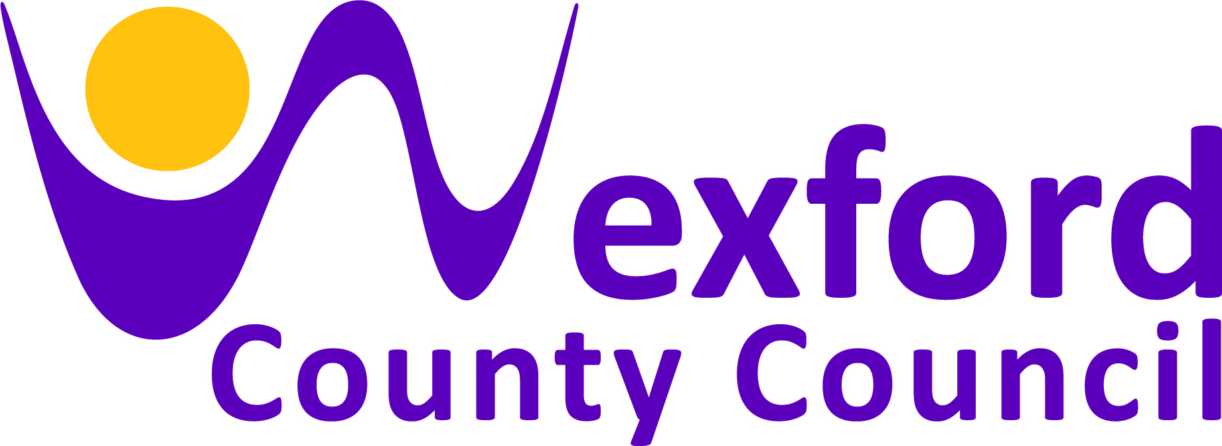

Regional Festival & Participative Events Fund 2019

Application Guidelines

The Regional Festival & Participative Events Fund 2019 for County Wexford aims to support festivals and participative events that will drive domestic tourism and help to improve the visitor experience in County Wexford.
The Programme is aimed at festivals and participative events that fit into one of the following categories:
• General festivals (i.e. literary, historic, traditional culture or family focused).
• Arts, Music & Theatre.
• Food & Drink.
• Sports & Outdoors.
• Business & Education.
• Other.
The following categories of festival and participative events are ineligible for this funding arrangement:
• Purely commercial events with limited tourism appeal.
- Agricultural shows and countryside fairs with limited tourism appeal.
• Spectator-based sporting events.
• Circuses and carnivals.
• Christmas fairs and markets.

Priority will be given to those festivals and participative events that best drive the economic contribution of tourism.

A minimum eligible expenditure of €5,000 must be demonstrated in the case of both festivals and participative events. Maximum funding under this scheme will not exceed 50% of the overall eligible costs.

Please Note: The overall fund for County Wexford in 2019 is €22,000 which will be allocated among successful applicants, with amounts awarded based on a competitive evaluation.

Closing date for receipt of completed applications is 26th April 2019. Applications received after this date will not be considered. Typical grants awarded are €1,500 to €3,000. In certain circumstances Wexford County Council may increase the grant awarded.

1. BACKGROUND

A new funding arrangement has been put in place between Fáilte Ireland and local authorities to drive the implementation of tourism focused festivals and participative events. This new funding arrangement will replace Fáilte Ireland’s existing annual Regional Festivals and Participative Events Programme and will commence in 2019.
Wexford County Council will be administering this funding programme for festivals and events in Wexford for 2019.

2. WHAT IS THE FESTIVALS AND PARTICIPATIVE EVENTS PROGRAMME 2019?

This programme is aimed at supporting festival and participative events which drive domestic tourism, help to improve the visitor experience and promote Ireland’s Ancient East as the most personally engaging cultural destination in Europe.

3. WHAT ARE THE QUALIFYING CONDITIONS & MINIMUM ELIGIBILITY THRESHOLDS FOR 2019?

To be considered for funding, applicants need to demonstrate that the project has a minimum eligible expenditure of €5,000. The project must take place before 31st December 2019. Retrospective applications for past events are not eligible.

4. WHAT MUST SUCCESSFUL APPLICANTS DO WELL?

- Help to build memorable visitor experiences in the locality
- The proposed festival/event programme will be comprehensive and professionally designed and motivating for the visitor.
- A clear business plan has been prepared to include a full income and expenditure budget for the event, and a comprehensive marketing and promotions plan.
- Where possible use digital technology to widen reach and impact.
- The profile of the organisers is appropriate to manage the calibre of the proposed event.
- Festivals/participative events awarded funding must be available to brief Fáilte Ireland Tourist Information Offices in advance about the event so that information can be shared with visitors.

5. WHAT CAN BE FUNDED?

Minimum eligible expenditure of €5,000 must be demonstrated in the case of both festivals and participative events. The following costs are eligible expenses and may be funded under the programme:

Marketing Activity: The cost of marketing activities with a regional and national reach. This may include advertising, public relations, digital marketing and similar activities. Eligible costs may also include the cost of site-branding the location
during the event.

Event: Expenditure incurred on elements which has not received grant aid from other public bodies (e.g. Arts Council) and is considered to deliver significant benefits to tourism.

Development Activities: For example, feasibility studies, training and branding consultancy activities may be covered once it is clearly of long-term benefit and or/raises the festival or participative event’s profile.

The following costs are ineligible for funding:

- Hospitality costs.
- Office / administrative expenses, for example: salaries, rent, phone, office supplies, postage, photocopying. Food, accommodation and subsistence for the festival delivery team.
- Capital costs.
- In general the cost of items for resale are ineligible, except where it can be demonstrated that they will deliver significant tourism benefits and where they have been expressly allowed in the letter of offer.
- Activities which have been or are being grant aided by other public sources (except where this co-funding arrangement has been acknowledged and expressly allowed in the letter of offer).
- Travel and related costs unless expressly allowed in the letter of offer.
- Activities that duplicate activities that Fáilte Ireland is already undertaking
- Activities undertaken outside the dates as specified in the Letter of Offer
- Recoverable VAT.
- In-kind contributions.
- Fines, penalty payments, legal costs, audit fees, financial consultancy fees.
- Trade Association membership fees or equivalent.

5. WHAT ARE THE EVALUATION CRITERIA?

Applications will be evaluated on their overall individual merit, while also having regard to the following:

- Experience Brand Fit
- Tourism impact
- Marketing (including Digital Marketing)
- Delivery Team
- Economic and social benefit to local communities

6. GRANT DRAWDOWN REQUIREMENTS

Grant payments will only be made to the body specified as the grantee. Subject to the business case, up to 50% of the grant may be paid in advance once the signed acceptance of the letter of offer has been returned.
The balance of any funding allocation will be paid after the festival/event has taken place. The claim for the balance of funding must be accompanied with the following:
- Copies of receipts / evidence of payment for eligible expenditure
- Post event summary and evaluation
- Evidence of the acknowledgment of the support of Wexford County Council
The balance of any funding allocation must be claimed in full by 4th January 2020 or funding will be forfeit.

7. CONDITIONS OF FUNDING

- The organisers of successful festivals/participative events must notify Wexford County Council in writing if the date(s) of the festival/participative event change.
- The total amount of funding cannot exceed 50% of eligible vouched expenditure, verified with receipts.
- Financial assistance provided under this scheme must be acknowledged by successful applicants in promotional materials. Wexford County Council, Fáilte Ireland and Ireland’s Ancient East logos should be prominently displayed.
- Successful festival/participative event organisers are obliged to consult Wexford County Council to ensure that the all required licences are in place before the event.
- If the applicant group/organisation is registered for tax purposes, then the group/organisation must be tax compliant. Successful applicants may be required to submit a Tax Clearance Access Number in advance of receiving payment under this scheme.
- Wexford County Council will not be responsible for any aspect of insuring grant aided festivals/participative events.
- Where relevant, successful festivals/participative events must have in place a policy and proper procedures regarding working with children and young people. Evidence of compliance with Child Protection legislation may be required before funding can be drawn down.
- Payment can only be made to the entity that made the original application.
- Unless agreed in writing beforehand, Wexford County Council reserves the right to withdraw or recoup any grant funding if the event does not take place, is changed, rescheduled, renamed or otherwise altered from that as submitted in the application.
- Wexford County Council encourages events across the county. Specialist advisors provide guidance so that these events are safe and fun for all in attendance. Anyone seeking to hold an event in a public space, at a Wexford County Council facility or on Wexford roads, must apply online for prior permission. The application form can be found at the main website www.wexfordcoco.ie under the link to Events Management. The form must be submitted in good time prior to the event, in line with the Wexford County Council Events Management Guide. This is also available on our website or can be provided in hard copy from the Council offices.

Please return completed application forms to:

Community Development Section
Wexford County Council
Carricklawn
Wexford

Or by email to: community@wexfordcoco.ie
Before 5pm 26th April 2019.

