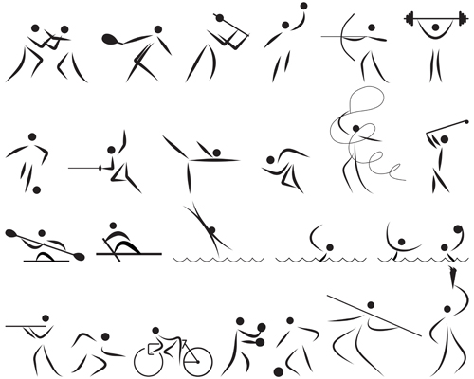

Local Sporting Champions Grant Scheme
  - Guidance Notes

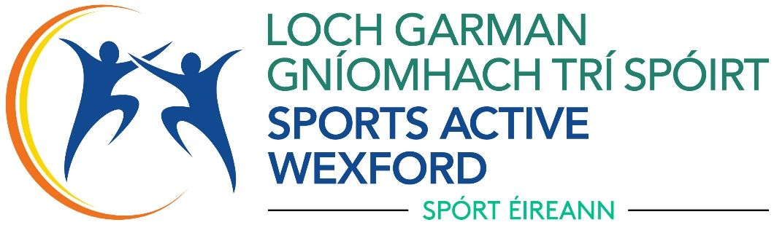

WHAT IS THE Local Sporting Champions Grant Scheme?
Wexford County Council is committed to supporting Wexford’s most talented athletes to reach world class podiums. As a result, a funding stream has been developed which is open to athletes, who are competing or aspiring at regional level (or equivalent) or above.
The aim of the scheme is to recognise individual talented sports performers in County Wexford and encourage them to develop to their full potential by providing funding to assist with the costs associated with competing at a high level.

WHO CAN APPLY?
- Applicants must be a permanent resident within County Wexford
- You must be competing at or aspiring towards National or equivalent level
- Applications from athletes striving towards Olympic and Paralympic Games, will be prioritised 2 years from intended participation. (Must be Verified by NGB)
- Your sport must be recognised and approved by Sport Ireland.
- Grants will normally be awarded to a maximum of 50% of total costs and will be allocated under three tier criteria.
- Previous applicants have been required to show significant progress in their chosen sport to be considered for a grant.
- Endorsement from your sport’s Governing Body must be submitted
- A higher priority will be given to individuals residing in designated areas of disadvantage.
- Representative Teams may apply but this will be assessed as one grant per club.
- Evidence that most of their training and sport is participated in County Wexford, and they are a member of a registered club based in the county.

WHAT TYPES OF ACTIVITIES MIGHT BE FUNDED?
Local Sporting Champions Grant Scheme will fund:
• Essential items of equipment required to compete and train.
• Cost of travel for training and competitions.
• Cost of facility hire for training.
• Coaching costs (but not a coach’s salary)

Athletes that are currently not supported by the Irish Institute of Sport may utilise funding towards support services (Physiotherapy and Strength and Conditioning). This must be from recognised providers.

HOW MUCH FINANCIAL ASSISTANCE IS AVAILABLE?
Tier 1: Up to €150: Where a young person is at the early stage of their development and promising in terms of commitment and skill. Beginning to have good success at competition with their coach and others seeing greater potential.
Tier 2: €150 - €250: Where evidence is provided of excellent ability and an outstanding commitment to training. Should be attaining good performances at county and regional events.
Tier 3: €250 - €350: For those competing at National or International level. Training with NGB performance squads.
Grants of up to €500 may be awarded to those representing the country in Olympic, Paralympic and European and World events where the sport is a part the recognised Olympic programme).
Individuals as a part representative teams or a club Team will be assessed but only one award per club may be awarded, Applications for multiple representation from one club must be made as one application. Grants will be allocated based on representation in the tiers above

  - HOW TO APPLY
There are some important steps to consider before applying to the Local Sporting Champions Grant Scheme.

Step 1: Read the Guidance to ensure that you meet the requirements.

Step 2: Complete the application and submit from two referees, one of which must be from a relevant national governing body representative officer or a national/international level coach, who is able to confirm that you are currently involved in your nominated sport to at least national standard or above.
Step 3: If you have any questions, please contact the Sports Active Wexford for clarification. The team can be contact on (053) 9196557 or by email at sports.active@wexfordcoco.ie
Step 4: Submit an application
If you decide to apply, contact Sports Active Wexford

If you do not have email access, you may send your applications to:
Local Sporting Champions Grants, Sports Active Wexford, Community Development, Wexford County Council, Carricklawn, Wexford.

Please note that funding is dependent on available funds and prioritising will be necessary. Wexford County Council therefore reserves the right to limit the amount of financial assistance given or the number of awards made to a single applicant/sports club.
Applications without all supporting evidence or incomplete will not be considered and will be returned without being assessed

WHAT HAPPENS NEXT
Firstly, your application will be acknowledged within five working days of receipt. Your application will be assessed (alongside all the other applicants) and make suitable recommendation.

HOW WILL APPLICATIONS BE ASSESSED?
- Eligible applications will be assessed using the information given as answers to each question in the application form; Applicants should answer each question in the application. Applicants that do not address each question adequately may not be considered.
- Please submit supporting information that may be relevant to your application.
- You must include details of the annual costs incurred through your involvement in your sport including accommodation, transport, competition entry fees and equipment etc.
- You must include letters from two referees, one of which must be from a relevant national governing body representative officer or a national/international level coach, who is able to confirm that you are currently involved in your nominated sport to at regional, national standard or above.
- Funding will not be awarded for retrospective costs. Any award made will be for the provision of future costs associated with your involvement in your sport.

CONDITIONS THAT APPLY TO APPLICATIONS AND FUNDING?
• Any funding awarded to you through this grant application process must be spent within one year of allocation of funding.
• Only 1 application per athlete/organisation will be considered per financial year
• Successful applicants need to acknowledge Sports Active Wexford and Wexford County Council support through the provision of a grant from the Local Sporting Champions Grant Scheme.
• You will be required to provide a report to Sports Active Wexford with any progress you are making in your sport. (This could include competition results, selection to represent teams, publicity, and recognition awards).
Successful applicants will be required to sign a grant agreement form before the grant will be issued.
• Funding of individuals through the talented athlete support programme carries certain responsibilities. Athletes may be required to be available for meet and greet with young aspiring athletes or for promotional events. While we recognise that the athlete will have training and competitive commitments you may be expected to attend no more than two events over the course of the year as part of the agreement to obtain funding.
Any successful applicant who is judged by their NGB to have brought their sport in to disrepute or receives a ban for doping offences within 5 years will be required to return the grant money.

PAYMENT

If your application is successful, you will be required to provide or confirm current banking details for payment. This will be requested in a form attached with your grant allocation notification.
Successful applicants will be required to sign a grant agreement form before the grant will be issued.

Payment will be made in line with Wexford County Council guidance as one single payment and receipts of expenditure sent into the above address by the end of the financial year.

