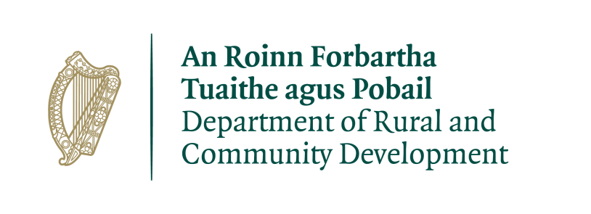

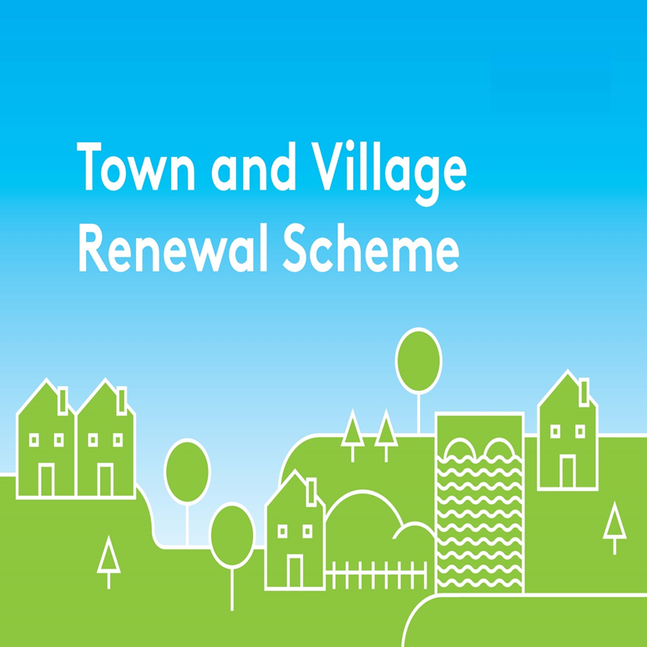

2018 Application Form

Application Form for the
Town and Village Renewal Scheme
2018

Please complete a separate application form in respect of each proposal

All queries can be addressed to: townandvillage@drcd.gov.ie

Application Reference No

APPLICATION FORM

This form should be completed by Local Authority personnel and returned by e-mail to townandvillage@drcd.gov.ie by 30th June 2018

Name of Local Authority:

Town/Village covered:

Please indicate which category of funding is being applied for:

Category 1 Category 2

Towns/Villages with Towns/Villages with

Population of 5,000 Population of

or less 5,001-10,000

NOTE: Minimum of 60% overall funding to be allocated to Towns with population of 5,000 or less.

Amount of Grant Funding Requested:

Local Authority:

Contact Name (Local Authority):

Contact email address:

Postal Address:

Telephone Office:

Telephone Mobile:

- Has the Local Authority conducted a consultation process with the
Town/Village concerned? Yes No

- Has this project been identified through the consultation process that was
carried out ? Yes No

- Has funding for this project ever been sought from other sources? Yes No
(If "YES" yes please specify from what source and if funding was provided)

- Was funding provided for this Town/Village under the Town & Village Renewal Scheme 2016/2017 or REDZ Pilot 2015/2016? Yes No
(If "YES" please provide information on amount of funding provided, amount expended and status of project e.g. expected completion date)

- Have all necessary planning permissions and consents been obtained for the project and any applicable heritage or environmental assessments completed? Yes No
(If "NO", please detail plans in this regard if relevant)

- If the project involves works on buildings or lands, does the applicant/partners own the premises where upgrade/refurbishment/improvement are proposed? Yes No N/A
(If "NO", please state who owns the building/land and outline proposals to ensure permissions are granted to carry out the work.)

- Who are the specific project stakeholders/community partners in this project i.e. Chamber of Commerce, Community group, etc. Please outline the consultation process that was undertaken.
- Synopsis of Project: (Max. of 300 words). A detailed project proposal should be appended to this application. (Maximum 5 Pages, up to 10 pages for projects in excess of €200k)

- Identify the Town/Village, explaining the rationale for the choice, identify existing assets, amenities, accessibility, environmental aspect, retail mix, etc., and any deficits that need to be addressed or opportunities that can be built on. Please refer to any Health Checks, LECPs, Local Development Plans/surveys that have been undertaken on the Town/Village.

- Please detail where the project proposal fits into the Local Economic & Community Plan (LECP), County Development Plans etc.

- Please detail how the project proposal displays an economic development element or how it will makes a sustainable, visible and positive impact on the town/village.

- If seeking funding of greater than €100,000, please provide details of the particular economic case for this level of funding (max of €200,000 available for a limited number of projects).

- What is the overall objective of the proposed project and how will the intended outcomes be measured? (Please identify any metrics or benchmarks that will be applied).

- If relevant, please give a brief outline of the tendering process planned/carried out in order to ensure compliance with Public Procurement Guidelines:

- Please give anticipated project commencement and completion dates

- FINANCIAL DETAILS
Local Authority VAT No.:
Tax Registration Number:
Tax Clearance Access Number:
CHY Number (if applicable):

- Detailed Costings for proposed Works
Please provide a detailed breakdown of all elements of the proposed works
(itemise various elements) | €
 | €
 | €
 | €
TOTAL COST | €
Grant Aid amount sought: (Max of 80% of Total cost) | €
Match Funding: (at least 20% of Total Cost) | €
of which – up to 10% may be “in-kind”: | €
With minimum Cash contribution of 10% | €
Nature and source of “in-kind” contributions:

DECLARATION
I hereby confirm that I have read and understand this document and declare that the particulars supplied in this application are true and correct. I request that assistance be given in support of the project as outlined and certify that, if made, the grant will be solely for the purpose for which it is approved.

Signature __________________________________________________

Position __________________________________________________

Date __________________________________________________

Note: All projects proposals must be supported by a fully completed Application Form. Only applications submitted by the Local Authority will be considered.
The scoring framework below will be applied to all applications in order to ensure that successful projects are of a high quality. A minimum threshold of 65% will be required for each criterion and the mark required to meet this is also outlined below.
Closing date for receipt of applications to townandvillage@drcd.gov.ie is 30th June 2018
Selection Criteria | Detailed Outline | Max Score | Quality Threshold
Economic Development Potential | - Does the project include activities that have clear positive economic impacts?  - Does the project complement or leverage other Government programmes and objectives?  - Does the proposal add value to current initiatives?  - For projects exceeding €100,000 does the project demonstrate a strong economic case? | 300 | 195
Strategic nature of the proposal and coherence with local area plans/healthcheck | - What evidence is there that the project proposal is in line with the aims and objectives of local area plans?  - Did the application seek input from local community or business interests? | 200 | 130
Demonstration of need and potential | - Does the project demonstrate a sustainable, visible and positive impact on the town/village?  - Does the proposal include a clear statement of identified needs?  - Does the proposed plan of action address the needs identified?  - Does the proposal show engagement with the local community and business interests in the formulation of the project proposal? | 200 | 130
Realistic nature of the proposal? | - Are a clear set of defined outputs and outcomes included in the proposal?  - Has a delivery mechanism been identified?  - Is there a process in place to measure outcomes and impact of the proposal over time? | 150 | 97.5
Value for Money | - Extent to which projects are clear and include targets, realistic costing and timescales.  - Clear rationale for costs requested.  - The cost effectiveness of the proposal with regard to the level, range and quality of outputs and outcomes to be delivered. | 150 | 97.5
Total |  | 1000 | 650

