

GUIDANCE FOR COMPLETING DERELICT SITES COMPLAINT FORM
please read carefully before completing the form

- Wexford County Council’s Role
Wexford County Council is responsible for dealing with derelict sites in its area. Under the Derelict Sites Act 1990, Local Authorities can force owners to clean up these sites. The Act allows Local Authorities to prosecute owners who do not comply with notices served, to acquire land compulsorily and to carry out the necessary work themselves and charge the owners for the cost.
Local Authorities have similar powers as regards dangerous structures.
- What is a derelict site?
Under the Derelict Sites Act 1990 (as amended), a derelict site means any land which detracts, or is likely to detract, to a material degree, from the amenity, character or appearance of land in the neighbourhood of the land in question because of the following:
- The existence on the land in question of structures which are ruinous, derelict or dangerous condition; or
- The neglected, unsightly or objectionable condition of the land or any structures on the land in question; or
- The presence, deposit or collection on the land in question, of any litter, rubbish, debris or waste, except where the presence, deposit or collection of such litter, rubbish, debris or waste results from the exercise of a right conferred by or under statute or by common law.

- What is not a derelict site matter?
The Derelict Sites Team does not investigate civil matters, for example:
- Land or ownership disputes.
- Trespass.
- Private nuisance (noise, vandalism, anti-social behaviour etc.)

Derelict Sites Complaint Form

Location of derelict site (Please give as much detail as possible and include an Eircode, a site location map or photos where possible)
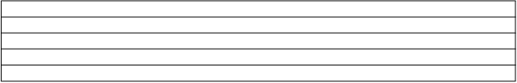

Name and address of all owners and occupiers, if known (including Eircode)
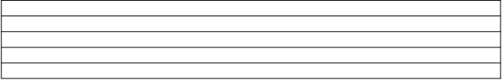

Reason for complaint (An extra sheet may be used to provide additional information if necessary)
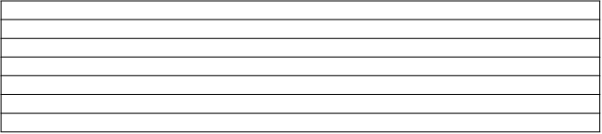

Name and address of person making complaint (including Eircode)

Contact details of person making complaint (including telephone number and email address)

Signed: _______________________________________

Date: _______________________________________

NOTE: Complaints may not be investigated unless a fully completed, signed and dated Complaint Form is provided, with the name and address (including Eircode) of the person making the complaint.

Please return completed forms to:

Derelict Sites - Planning
Wexford County Council
Carricklawn
Wexford
Email: derelictanddangerous@wexfordcoco.ie

IMPORTANT DATA PROTECTION INFORMATION: PLEASE READ

The Council has a Privacy Policy which is a general document about how we approach data protection as an organisation. This is available on the Council’s website (Wexford-County-Council-Data-Protection-Policy-GDPR-18.pdf). Access to the data is controlled and restricted to relevant staff of Wexford County Council involved in Derelict Sites. All correspondence in relation to Derelict Sites, including your personal data, will be held and disposed of in compliance with the National Retention Policy for Local Authority Records which can be accessed at the following link: https://www.lgma.ie/en/publications/corporate/national-retention-policy-for-local-authority.pdf
If any of your personal details change, please advise the Derelict Sites Team on derelictanddangerous@wexfordcoco.ie or telephone (53) 9196101.

CONSENT
Do you consent to the information on this form supplied by you, to be held on file by Wexford County Council for the purpose of regulation of Derelict Sites under the Derelict Sites Act 1990, as amended: Yes No
\
\

\
\

Please tick your preferred method to be contacted (√):

Do you give consent to Wexford County Council to be contacted by:

Phone
\
\

Email
\
\

Post
\
\

You can withdraw your consent at any time by telephoning (053) 9196101 or emailing: derelictanddangerous@wexfordcoco.ie

ADDITIONAL INFORMATION

