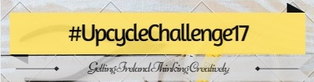
Entry Form
Name: |  | Phone:
Email:
Address:

Please tick: Group/Organisation School Individual Men’s Shed Other

List materials used:
New | Reused  (Please describe where you sourced your reused items)

Describe what you did with the item(s) you upcycled:

If selected as a finalist, you will need to be available for the presentation in October (2017). Location of presentation event TBC. There will be a winner in each region – Southern, Eastern-Midlands & Connacht-Ulster.

