Rates Relief Grant Scheme for Community Based Facilities
Applicable to Charities, Not for Profit Organisations, Sporting Bodies and other Community Facilities.
The Rates Relief Grant Scheme is intended to acknowledge the charitable and community contribution of worthy organisations throughout the county, whilst providing a fair-trading situation for all rate paying businesses.

All organisations applying for the grant must first seek a determination by Táilte Eireann on the applicability, or not, of an exemption under Section 4 of the Valuation Acts.

If Táilte Eireann has then assigned a rateable value to the property, the relevant organisations can apply for the Rates Relief Grant Scheme.

The level of grant available is 100% of the annual Rates Bill - but eligibility for this will be dependent on the type of organisation and the trading location of the organisation.

Approved Community Based Facilities in rural locations will receive 100% grant. Any premises outside the town boundaries for Wexford, Enniscorthy, Gorey, and New Ross are deemed to be rural locations for the purpose of this scheme.

The major retail districts for each urban centre in the county are highlighted on the maps attached. These areas are deemed to be fully commercial for the purpose of this scheme. Therefore, regardless of the status of the facility as community based, if it is located in these designated areas, rates will be payable in full.

Organisations deemed to be eligible for such a grant include but not limited to:
- Sporting groups (training facilities only, not bar/shop or where the premises can be rented out)  - Tourist Sites (no cafes/shops etc.)  - Chamber of Commerce offices | - Community groups (Men’s Sheds etc.)  - Community Facilities (Swimming pools etc.)  - Religious Groups  - Counselling services (non charging)

Every organisation seeking relief under this scheme for their Community Based facility will be required to make an annual application providing relevant data and certifications to allow Wexford County Council determine the appropriateness of the approval of such a grant.

Wexford County Council reserves the right to make the final decision on all grant applications. The time frame for receipt of applications is from when the annual Rates Bill is issued, to 30th April.

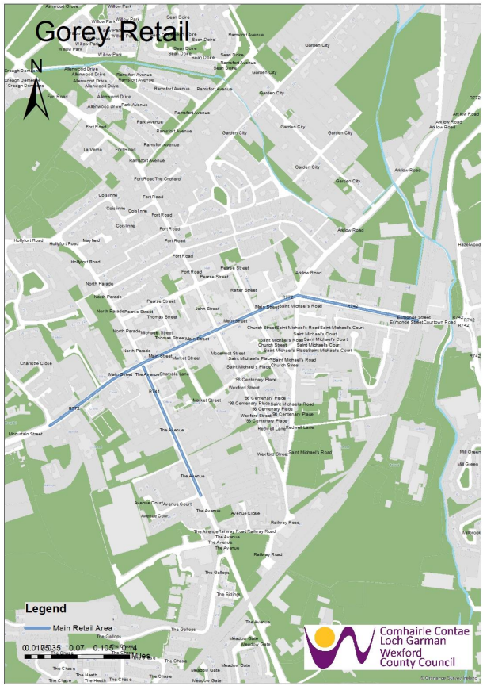

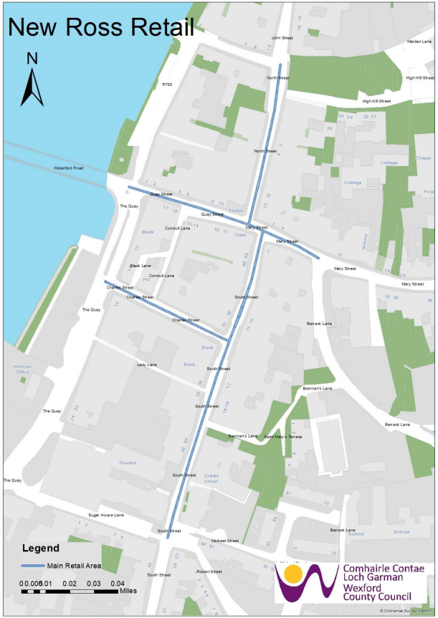

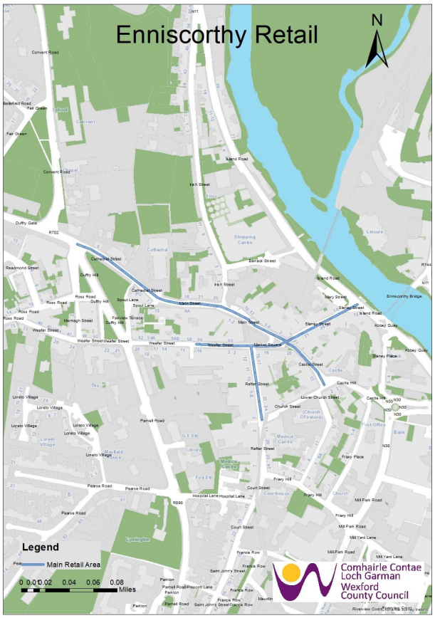

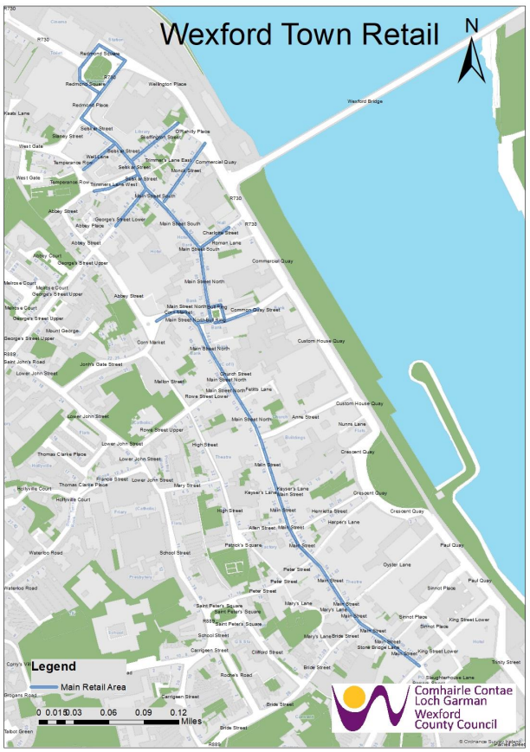

Step 1 – Has the premises been deemed exempt from Rates by Táilte Eireann – Yes/No
Step 2 – If “Yes” 100% relief is given, If “No”, what type of business is operating from the premises, i.e. commercial or non-profit, if commercial 0% relief is given.
Step 3 – If wholly non-profit where is the premises located? Urban/Rural
Step 4 – If “Rural” 100% relief is given following the determination of the type of business by Wexford County Council.
Step 5 – If “Urban” is the business located in one of the designated Major Retail Districts, if yes 0% relief is given, if no 100% relief is given.
NO
What type of business is in place?
The Rated Occupier must apply to Táilte Eireann to seek an exemption from Rates. Having looked at the evidence presented, TE will determine if a zero rating applies.
YES
Commercial
Non Profit
Is the property located within the designated Major Retail Districts
YES
NO
100%
0%
100%
Rates Relief Amount
0%

