Not Around Us Supporting Events Graphics
The style and type of promotion may dictate which logo you use. Below are some options.

Full Graphics in three different shape types
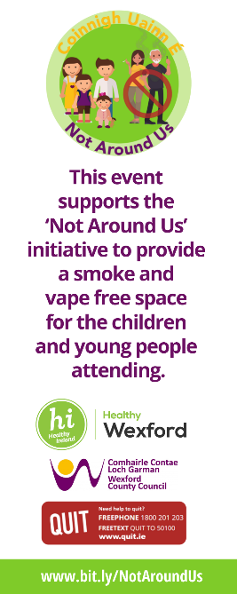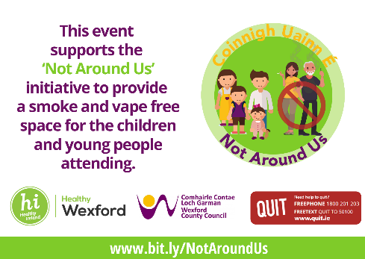

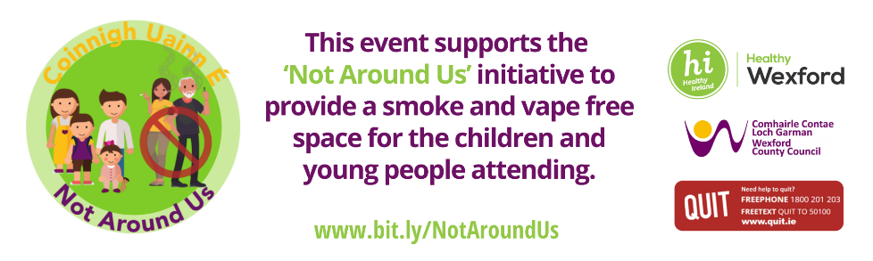

If the promotional material does not allow for use of the full graphic we would ask that you include the following text line and the logo below:
‘This event supports the ‘Not Around Us’ initiative to provide a smoke and vape free space for the children and young people attending’
