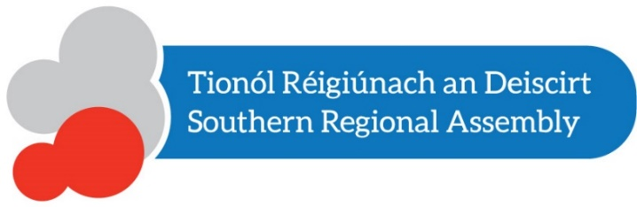

Draft Regional Spatial and Economic Strategy

for the Southern Region

Dréacht Straitéis Réigiúnach Spásuil agus Eaconamaíoch – Réigiúnach an Deiscirt

Public Consultation Days / Laethanta Comhairliúcháin Phoiblí

The Regional Spatial and Economic Strategy (RSES)/ Dréacht Straitéis Réigiúnach Spásuil agus Eaconamaíoch (SRSE) will provide a long-term regional level strategic planning and economic framework, in support of the implementation of the National Planning Framework, for the future physical, economic and social developments for the Southern Region.

The Southern Regional Assembly has prepared a draft Regional Spatial and Economic Strategy (RSES) for the Southern Region covering the period 2019-2031 and is seeking submissions.

The Southern Regional Assembly will consider all submissions made in writing between Tuesday 18th December 2018 and on or before 5.00pm Friday 08th March 2019 before adopting the RSES.

For more on the draft RSES consultation process see the Southern Regional Assembly website.

The Assembly will hold a series of public consultation days on the draft RSES during February where the team will be available to discuss the document:

Cork: Millennium Hall, Cork City Hall, 2.30-6pm, Monday, 11th February 2019
Limerick: O'Brien & Wogan Suite (Level 6), Strand Hotel, Limerick 2.30-6pm, Wednesday, 13th February 2019
Waterford: Dunmore Room, Tower Hotel, Waterford 2.30-6pm, Friday 15th February 2019

These will be open ‘drop in’ events and no registration is required.

Submissions or observations can be made via:

Online: The draft RSES documents and the submission form are available here.
Email: rses@southernassembly.ie
Mail: RSES Submissions, Southern Regional Assembly, Assembly House, O’Connell Street, Waterford X91F8PC
Please note that submissions may be published on our website and subject to Freedom of Information. Receipt of submissions will be acknowledged however it will not be possible to issue individual responses.

