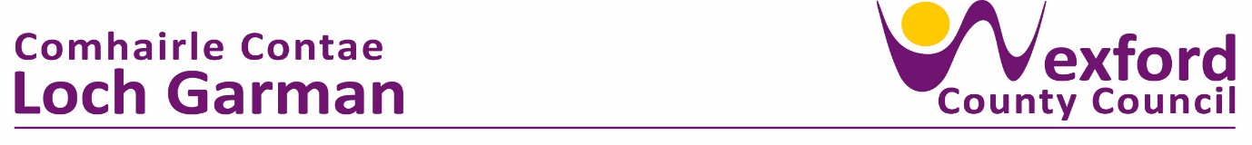**Press Release 10th January 2024**

**Wexford Co. Council and Wexford Local Development sign Framework Agreement worth up to 15.5 million euro**

On 19th December 2023, Wexford Co. Council and Wexford Local Development signed a “Framework Agreement” worth up to 15.5 million euro for “Social Inclusion and Related Services” over the next 5 years.

The Framework agreement will facilitate the awarding of social inclusion contracts to Wexford Local Development within the 5-year period of the agreement and includes an initial Call-Off Contract relating to the national “Social Inclusion and Community Activation Programme” (SICAP) 2024 – 2028 worth just over €10m.

SICAP is currently delivered by Wexford Local Development through a team of professional community workers who work alongside local communities in collaboration with a number of different agencies with a focus on targeting those who are most disadvantaged in Irish society. It is a targeted, holistic programme for those groups and individuals who are most disadvantaged and less likely to connect with mainstream services.

Following a procurement process, WLD have been successful in securing the contract for the delivery of the programme again for the next 5 years. The programme has been active in County Wexford for a number of years, and this is the third iteration of SICAP. Target groups are pre-defined nationally and include those who experience multiple inequalities namely; People living in disadvantaged communities, People impacted by educational disadvantage; People living in jobless households or households where the primary income source is low-paid and/or precarious; People who are long-term unemployed; People with a criminal history; Refugees; International Protection Applicants; People with Disabilities; Heads of One-parent Families; Travellers and Roma.

Wexford Local Community Development Committee (LCDC) have also chosen 3 “Local Priority Target Groups” for a specific focus for the duration of this new programme which are:

* People living in disadvantaged communities
* People impacted by educational disadvantage
* Travellers

Promotion of climate justice, with a focus on facilitating a just and equitable transition to a greener economy and society, will also be a horizontal theme in the new programme.

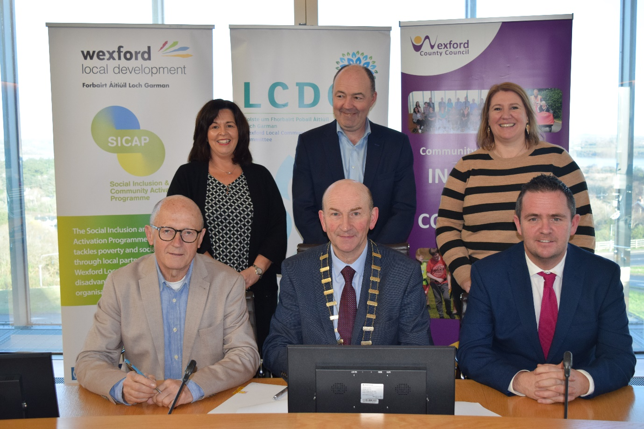

**Back row (L to R): Clare Ryan (Project Manager WLD), Brian Kehoe (C.E.O WLD), Carolyne Godkin (Director of Service, WCC)**

**Front row: (L to R): Michael Wall (Chairperson WLD), Cllr. John Fleming (Cathaoirleach WCC), Cllr. Aidan Browne (Chairperson Wexford LCDC)**

Speaking at the signing of the programme, Cllr. Aidan Browne said “As Chairman of the LCDC, I look forward to the continued collaboration between Wexford LCDC and Wexford Local Development, in delivering this key inclusion programme across County Wexford”

Cllr. John Fleming, Chairman of WCC said “I’m delighted to see this level of resources being allocated to the county to ensure social inclusion continues to be delivered to a high standard to those areas, communities and individuals where their need is highest. Wexford continues to experience significant deprivation in specific areas and programmes such as SICAP ensure that every effort is made to reach those most in need of additional supports”.

Carolyne Godkin, Director of Services with responsibility for Community Development added “We are delighted to continue this relationship with Wexford Local Development for the delivery of these important services to the county. WLD are highly experienced in the area of social inclusion. SICAP is making a real difference to the lives of disadvantaged people and communities in Co. Wexford. Building on the strong foundations already in place, this new programme will ensure continuity of community-based supports where it’s needed most.

Programmes Manager with Wexford Local Development, Clare Ryan spoke of the vital importance of SICAP in addressing inequality and improving outcomes for the most disadvantaged groups and individuals in the county. “Equality is about securing equality of opportunity, equality of participation and equality of outcome. What this contract effectively means is that it enables us to provide professional community workers on the ground who directly connect and work alongside those communities most marginalised and impacted by poverty and inequality”.

Adding to Ms. Ryan’s comments, the CEO of Wexford Local Development, Brian Kehoe said “We are working to reduce poverty and promote social inclusion at a local level, in practical ways; helping those in need to find work or to upskill, assisting many with accessing a tailored personal development course or gaining access to workplace skills or educational opportunities. SICAP helps to connect to those who are struggling, helping to point them towards a pathway of opportunities that might otherwise be missed or out of reach. Over the last 5 years through the current SICAP programme we have provided tailored supports to over 5,000 individuals. Our SICAP team are highly experienced and skilled in developing these connections and building capacity in the heart of local communities across Co. Wexford. We’re delighted to be able to continue this important work over the next five years”.

For more information on SICAP visit <https://www.wld.ie/social-inclusion-community-activation-programme-sicap/>

ENDS